Thinking BIG about Small Economies:

From *Open and Nimble* to Talented Workforce

Eighteenth Annual William G. Demas Memorial Lecture

Annual Meetings of the Caribbean Development Bank

Turks & Caicos Islands, Providenciales

May 23, 2017

By Daniel Lederman

Deputy Chief Economist for Latin America and the Caribbean

The World Bank Group

Contents

Prelude 2

The Legacy of William G. Demas 3

Thinking BIG about Small Economies: Believe, Innovate, and the brain Gain 5

Believe: The Aspirations and the Reality of Development in Small Economies 5

Innovate: On Being *Open and Nimble* 7

The brain Gain: Economic development by the people in small economies 10

References 14

Figures and Tables 15

Figure 1: Partial Correlation Government Spending/GDP and Labor Force Size, 1990-2013 15

Figure 2: Openness and Labor Force Size 16

Figure 3: The Number of Export Products and Services and Labor Force Size 17

Figure 4: Partial Correlation between Terms of Trade Volatility and Export Products 18

Figure 5: Export-Product Churning across Countries of Different Sizes and Over Time 19

Figure 6: Emigration Rates and the Size of the Labor Force 20

Table 1: Determinants of Remittances as a Share of GDP, 1990-2013 21

Table 2: Determinants of Labor Force Participation, 1990-2013 21

# Prelude

Dr. Warren Smith, President of the Caribbean Development Bank; Board Members of the Caribbean Development Bank; Colleagues: and Friends. Thank you very much for inviting us to be here with all of you.

My name is Daniel Lederman. I am the Deputy Chief Economist for Latin America and the Caribbean of the World Bank Group.

I was born in Santiago, Chile. My father was born in Hungary, my mother in Chile. I guess that makes my brothers and I first-generation Chileans, at least by fifty percent.

Political instability that turned violent at times in Chile forced my parents to leave their beloved country where they had grown up. Our flight from our national politics in the early 1970s taught me many lessons, as my family moved North, first to Costa Rica, and then to Mexico, ever so close to the United States.

Above all, I gained an appreciation for the community of the Americas; so rich, so diverse… and so very complicated.

I also learned what it feels like to be an immigrant minority in foreign lands. To paraphrase Ariel Dorfman, a Chilean playright, my parents never stopped “looking south while heading north”; always wanting to return to their beloved Chile while life took them further North, closer and closer to the United States.[1]

My brothers and I, however, found love and other pitfalls in North America. Our parents returned to Chile in 1991. My two brothers and I stayed in the United States after graduating from higher-education institutions.

When our parents fell ill or were navigating financial dire straits, we helped them, returning to Chile periodically and supporting them financially from afar.

This story of emigration, motivated not by a desire to leave behind our nation, but by the instability that uprooted families and affected many of our societies in the Americas, is, I am sure, well understood by many of you. And it is, in my view, a fundamental aspect of thinking BIG about small economies, because the diaspora plays a crucial role in shaping the path to prosperity for the Caribbean.

But first, allow me to reflect on the legacy of William Gilbert Demas.

# The Legacy of William G. Demas

I stand before this distinguished audience, humbled by the honor of being invited to deliver the Eighteenth Annual William G. Demas Memorial Lecture.

During his first stint as a policymaker, William Gilbert Demas was Adviser on trade policy to the West Indies Trade Commissioner in London from 1957 to 1958. These were historic times for the Caribbean, but also for the regional integration movement throughout the Americas.

As you all know, the *West Indies Federation* was founded in 1958. This historic moment for the Region, and indeed for the broader Americas, came after Doctor Demas’ early academic formative years at the University of Cambridge and as a researcher at Oxford.

Yes, we know. The West Indies Federation took time to succeed; but it was not a failure.

The British Caribbean Federation Act of 1956 started the process of creating the West Indies Federation. The Federation consisted of ten British territories including Antigua and Barbuda, Barbados, Dominica, Grenada, Jamaica, Montserrat, Saint Lucia, St Vincent, Trinidad and Tobago, and what used to be known as the St Kitts-Nevis-Anguilla territory. The stated goal was to foster not only an economic union, but, importantly, a political union among the British territories in the Caribbean.

In a prelude of the tensions that emerge between regional integration and sovereignty, this effort stumbled when Jamaica voted to leave the West Indies Federation in 1961 and move towards independence, with other territories including Demas’s own Trinidad and Tobago following its lead. Nonetheless, the Federation formed the basis upon which future integration efforts were pursued, thus laying the path for the eventual formation of the Caribbean Community (CARICOM) in the early 1970s.

From where I stand, there is at least one clear lesson from the history of economic integration efforts in the Caribbean: Without the early attempt to form the West Indies Federation, the Caribbean Community would not exist today.

And without William Gilbert Demas’s relentless leadership, including three years as Secretary-General of the Caribbean Free Trade Agreement (CARIFTA) and one year as the leader of the Caribbean Community (CARICOM) during 1970-74, CARICOM would not stand today as one the most durable efforts to support deep regional economic integration as a cornerstone of a development strategy for small economies. In my view, it is not a historical coincidence that the treaty that established CARICOM in July 4 of 1973, was signed in (Chaguaramas) Trinidad and Tobago; William Gilbert Demas’s birth nation.

For nerds like me, what is particularly impressive about William Gilbert Demas’s multifaceted accomplishments, is the profundity of his scholarship on the development experience of small economies. [2] His scholarly writings raised analytical issues related to the degree of openness of small economies, their patterns of trade specialization, and the policy implications that often clashed with aspirations of sovereignty. But he persisted and stood by his conviction that deep integration arrangements can help small economies prosper and, in a deeper sense, own our destinies more effectively than without integration with our neighbors.

In his 1974 collection of papers published in a book titled *West Indian Nationhood and Caribbean Integration*, Dr. Demas wrote:

“Because the world is dominated by the phenomenon of power, *effective* and not *formal* sovereignty is what really matters.”[3]

The profound realization that *effective* sovereignty is enhanced by economic integration, particularly regional economic integration, is, to this day, a source of inspiration for us, for our fellow citizens, for the broader Caribbean community.

In *Better Neighbors*, the World Bank Group’s most recent flagship report on Latin America and the Caribbean, we argue that it takes a “competitive region to make a competitive economy.” Simply put, William Gilbert Demas was right: effective sovereignty is achieved by seeking shared solutions to common challenges faced by small economies here, and elsewhere around the globe.

And so, we are gathered here today, in the beautiful British Overseas Territory of the Turks and Caicos Islands, to celebrate the Caribbean Development Bank. This venerable institution is yet another historical legacy of William Gilbert Demas’s leadership.[4] The central theme of these Annual Meetings is, once again, as I am sure it has been on previous occasions, economic integration and economic growth.

It is remarkable and worthy of remembrance that by focusing on the Caribbean but not limiting his analyzes to the community of nations that he cherished, William Gilbert Demas argued, convincingly, and that economic size per se brings sovereign nations together. We are brought together not necessarily by common heritage or ethnicities. Not even by similar economic structures. What really creates a sense of unity is a set of common challenges that small economies around the world cannot avoid. And the community of Caribbean nations is not an exception – we face common challenges that are best addressed with shared solutions.

The 2011 Demas Memorial Lecture was delivered by Dr. Ngozi Okonjo-Iweala, a former Managing Director of the World Bank Group and Minister of Finance of Nigeria. Ngozi felt strongly that living in small economies, and small island states in particular, presents challenges, but more importantly it presents opportunities.

We have the distinct opportunity to unite economically, but more importantly, to unite around a common purpose to focus on a brighter future for our fellow citizens.

# Thinking BIG about Small Economies: Believe, Innovate, and the brain Gain

Let us think BIG about development in small economies. Let us think BIG about what the Caribbean can accomplish together.

Beyond our shared sense of purpose, of our shared mission to improve the livelihoods of all Caribbean citizens, today I want to share with you a few ideas about what it means to think BIG about economic growth in our nations and territories, and more generally for small economies around the world.

Thinking BIG about small economies begins with aspirational goals – we must believe that the challenges of small economies can be overcome.

But it goes well beyond aspirations. It is about pushing the envelope; it is about looking for ideas in areas we have not explored before. And if we have explored all areas, it is about seeing the big picture that tells us how seemingly unrelated opportunities are actually connected in the process of economic growth.

My speech here today is nothing more than an invitation. An invitation to think BIG: to Believe, to Innovate, and to Gain the appreciation of our citizens.

# Believe: The Aspirations and the Reality of Development in Small Economies

Believing that a brighter future is attainable is about our aspirations as leaders of the Caribbean people. When it comes to economic development or economic growth, the aspiration is obviously to raise the standard of living of our populations.

So what is the evidence regarding the potential of small economies?

The evidence speaks loud and clear: Small economies do grow fast and many are already among the world’s most prosperous economies.

As an example Luxembourg, a small landlocked country in Europe, is among the world’s richest economies in per capita terms. Singapore is a small island nation that has achieved very high GDP per capita. In fact these two economies were both among the top 5 countries in the world in terms of GDP per capita in 2015. Within the community of the Americas, some of the richest economies are actually small: The Bahamas, Barbados, Trinidad and Tobago, Uruguay in South America, all have incomes per capita (adjusted for purchasing power) that put them among the richest economies in the Americas south of the U.S.-Mexico border. This is not to say these economies do not face challenges and that we can be complacent. On the contrary, even rich economies must confront their challenges. But believing that we can overcome them is a starting point for taking action.

Current levels of development were achieved through a history of economic growth. So how about current growth experiences?

The evidence is equally clear: Some of the fastest growing economies from around the world are small. One example with which I am sure many of you are familiar is Mauritius which has been achieving high growth rates for decades now. In the Americas one can look to Panama, Costa Rica, and the Dominican Republic for examples of small economies that have been growing rapidly since the onset of the 21st Century.

In other words, what makes small economies unique is not a lack of potential to grow.

This is as true today, as it was true in 1965 when Doctor William Gilbert Demas published his book titled *The Economics of Development in Small Countries with Special Reference to the Caribbean*. A review of this insightful book published in the *American Economic Review* stated:

“The rather atypical feature of the Caribbean economies, again in comparison with other Latin American countries, is monetary stability, high per capita incomes ($1058 and $706 for Trinidad and Tobago and for Jamaica, respectively, in 1962), and high annual rates of growth in GDP (around 8 per cent per annum in the 1950's).”[5]

I will return to the issue of monetary stability in a few minutes. For now, the point is that small economies can and do grow fast, and thus are able to offer improvements in social wellbeing for our societies.

We can and must believe that small economies can find a stable growth path to prosperity.

The more interesting analytical question, therefore, is: How can this be true when most economists believe that economies of scale are a fact of life? To make a long story short, before making it longer, small economies have found a way by being Open and Nimble. But to create nimble economies, small economies innovate.

# Innovate: On Being *Open and Nimble*

This question brings me to our forthcoming coming book titled “Open and Nimble: Finding Stable Growth in Small Economies.” This title will hopefully make sense to you in a few minutes. Let me try to explain.

In economics, “economies of scale” imply that the *unit costs* of producing goods or services depends on the volume of production. When production entails making investments whose value does not affect the quantity produced, the unit costs of production will tend to fall with the volume of production, up to a certain point, when all the so-called *sunk costs* (or *fixed* costs) of production become negligible relative to the *variable costs* of production.

Like many economic and social phenomena, economies of scale are difficult to spot across countries. We usually find them in micro data; we find them in the production of firms, enterprises and industries, less so in Gross Domestic Product (GDP).

Nevertheless, in *Open and Nimble* we gave it a shot. It turns out that we found evidence of economies of scale, as some academics did in the past, in a couple of interesting dimensions.

First, we found them in the size of governments, of public sector expenditures to be more precise. The data is consistent with the existence of economies of scale in the provision of public services. More specifically, the size of government as a share of Gross Domestic Product (GDP) tends to decline with the size of an economy’s workforce (or working age population). This relationship holds even after controlling for the level of development (proxied by GDP per capita). (See Figure 1)

Think of a sovereign government. It requires the establishment of a minimum standard of institutions and government agencies. When one setups a Foreign Service, we need embassies and perhaps a Foreign Service training institution. Since the number of partners around the world is fixed, running a Foreign Service requires a certain amount of investment regardless of the size of the country operating it. Likewise, if a sovereign nation wishes to have a Central Bank, a minimum level of institutional capacity and technical expertise, as well as a building, are required. But once the basic institutions and human capital are established, one can add personnel and make further investments to expand the number of citizens that benefit from consular services or increase the number of financial regulators as the number of financial entities that needs regulating expands. This can be accomplished by paying a relatively small additional (or marginal) cost.

There are many other examples in social policy areas, about which we can talk later. The point is that it is reasonable to interpret the evidence of a negative correlation between the size of government relative to domestic production and the size of an economy’s labor force as evidence that scale economies exist in the provision of public services. From a policy viewpoint, this implies that innovation in public-sector efficiency is even more important for small economies than elsewhere; it is the proverbial bicycle that one needs to keep pedaling if we want to keep moving forward.

The second area in which we found evidence consistent with *diseconomies of scale* in small economies is in international trade.

Here we found that large economies tend to export more products and services to a larger number of export markets than small economies (see Figure 3). This positive correlation between export diversification (across both products and markets) and economic size is consistent with the idea of diseconomies of scale. Exporting a product or service to a given market requires a minimum level of production in order for the enterprise to be profitable or globally competitive. Each export product or service will require a minimum number of workers, including managers and salaried workers. Small economies, consequently, are likely to have fewer export products or services in their production portfolios than larger economies. Furthermore, small economies are also more likely to specialize in exports that themselves can be produced profitably at small scale than products that are typically found in the export baskets of large economies, such as manufactured goods like electronics and pharmaceuticals.[6]

Now, back to the original question: how can small economies around the world be as or even more successful than large economies, both in the past and in the current historical juncture, if diseconomies of scale are a fact of economic life?

Our answer is that they can be successful by being *Open and Nimble*.

*Open*, because small economies do tend to be more exposed to international trade, as a share of GDP, than large economies (see Figure 2). In the United States, there is a lot of trade between New York and California, and less trade with the rest of the world. Small economies may not have large domestic markets but we have trade with the world, and particularly with nearby large markets, which allows us to achieve economies of scale in production, but while producing and exporting a small portfolio of goods and services.[7]

So, being *Open* is one unique characteristic of small economies; export concentration is another (see Figure 3). But export concentration presents challenges for economic growth and development. This is so because the volatility of the average price of an economy’s exports, and therefore of its terms-of-trade, depends on the number of products and markets in a country’s export basket (see Figure 4).

Many of you have certainly heard the phrase “do not put all your eggs in one basket.” The economic interpretation is that if all your national production is concentrated in one basket, in one type of good or services, then this basket will be risky, as it will fluctuate with the ups and downs of one particular global market, as opposed to having many such baskets in the form of a variety of products and services.

So, how have small economies overcome the challenge of external volatility that is consequence of being specialized in a few products or services? They are more *Nimble* than large economies.

Although this unique ability of small economies to Innovate, to reinvent ourselves, has not been studied until recently, the evidence is clear to us:

Small economies appear to have an uncanny ability to reinvent themselves more quickly and more often than large economies. Simply put, they are more likely than large economies to innovate by introducing new exports and letting go of old ones. In economic jargon, small economies tend to have higher rates of export-product churning than large economies (see Figure 4). And this unique characteristic of being small helps ameliorate the volatility caused by fluctuations in global demand for specific goods and services.

By being innovative, small economies become more nimble than large economies. Yet this nimbleness by itself might not be enough to send us on a path toward stable growth. It does mean, however, that fiscal policies, specifically countercyclical fiscal policies become even more important for small economies than for large economies.[8]

In sum, in *Open and Nimble*, we argue that by being open and nimble, small economies have been able to overcome challenges of diseconomies of scale. Our hope is that this part of the story sounds familiar to many of you. Small economies can and do innovate while remaining open to international trade, but this is accomplished while also having large governments (as a share of GDP).

What is less obvious is how the societies of small economies have also adapted over time in ways that makes their labor markets unique.

This idea brings me to the third element of thinking BIG, which is economic development by the people focused on brain Gain -- the antonym of brain drain.

# The brain Gain: Economic development by the people in small economies

Tonight I began this lecture by sharing my personal experience with migration, and the human desire to support our families that we have left behind. Although these are highly personal decisions, economists have terms that sap the emotion out of most social phenomena. Of course, I am talking about remittances, which are private transfers between private individuals who live in different countries. As remittances flow in, families can attain a higher level of welfare since these transfers can complement or even substitute for income generated within the borders of our countries.

However, I must confess: this is the aspect of my lecture for which I have even less clear answers, but perhaps more important questions.

So let me take you through my train of thought, from being *Open and Nimble* to development based brain Gain, by leveraging our talented population.

As many of you know from your daily lives, small economies are societies where people move across borders in search of economic opportunities. In this context, economic growth depends on the number of people that work within the borders of our countries. But the welfare of our fellow citizens depends not only on what we produce at home and sell to our global customers; it also depends on the earnings of our emigrants.

Perhaps more importantly for us tonight, economic size plays an important role in determining the level of emigration, which in turn determines the size of international remittances. (See Figure 6 and Table 1.) Yes, economic size is not the only factor that shapes both emigration and the magnitude of remittances that are sent back to our places of birth. Both are also affected by the quantity and quality of economic opportunities offered at home. But the evidence does suggest that economic size per se, after controlling for the effect of the level of GDP per capita in our home countries, contributes to emigration, and through this channel, to remittances.

Let us think about this for a moment: Our people emigrate even from relatively rich and open small economies. It could be due to volatility, economic as well as social or political, as was the case of Chileans in my personal story. It could be because of violence and personal insecurity as well.

But it can also be due to economic size, through its effect on economic specialization. Simply put, the smaller the economy, the less variety of economic opportunities and amenities. Thus, it is likely that small economies must learn to live with a brain drain that cannot be completely halted. But, it is clear that brain drain is not an unsurmountable obstacle in the road to prosperity, because we know that small economies can succeed even when their emigration rates are high.

Still, labor markets in small economies might not function in the same way as labor markets in large economies, precisely because emigration and remittances can affect the functioning of labor markets. Indeed, existing research on remittances and development highlight several challenges that might arise as a consequence of remittances.[9]

One aspect is particularly important, namely how remittances, these private transfers that occur often within families, can affect the incentives for labor-market participation among working age adults.

For the sake of clarity, let me summarize briefly what we know about the chain of causality from economic size to emigration, remittances and labor markets:

* First, small economies tend to have higher emigration rates than large economies, for the reasons I explained earlier.
* Second, these higher emigration rates produce higher remittances as a share of GDP.
* And, third, higher remittances as a share of the GDP are associated with lower rates of labor-market participation. (See table 2.)

The last point can have profound implications for labor-market policies and growth. Income transfers from any source, either private or public transfers, can affect individuals’ decisions about work. Economists use the term “reservation wage” to characterize an unobserved minimum wage below which people are not willing to work. If families or individuals receive transfers, this reservation wage can be higher than otherwise. The conventional wisdom is that poor families have very low reservation wages, whereas rich families have very high reservation wages. Hence public transfers, for example in the form of Conditional Cash Transfers (CCTs), work best when they are precisely targeted on the most vulnerable families, particularly female heads of households. This targeting thus prevents these public transfers from becoming disincentives to work.

Remittances, and private transfers more generally, present complications for our understanding of how labor markets work precisely because they are not the result of decision taken by the proverbial “central planner.” In most countries, the government cannot or does not interfere with the flows of remittances, above and beyond the effects of income or consumption taxes and general capital controls.

All this means that remittances can reduce labor-market participation by otherwise talented, capable workers. And small economies tend face this challenge writ large. To complicate matters even further, low participation rates imply that the tax base (for raising public revenues) is also lower than it would be otherwise without private remittances flowing in.

I know. Not every labor-market syndrome is caused by remittances or private transfers between family members. But in economies where the share of remittances over GDP exceeds 5-10 percent, they probably have a notable impact. At least that is what the data indicates (again, see Table 2).

Let us think about this: do the mainstream policy recommendations (including from the World Bank and the International Monetary Fund) with regards to labor markets apply to all economies around the world, regardless of the size of their remittances or economic size? Tonight, I would like to put on the table, for your consideration, that the answer to this question is, at least, *possibly* not.

The key labor-market challenges in small economies with high emigration rates, high remittances (as a share of GDP) and low labor-market participation rates are, therefore, twofold: to make our economies more attractive for our homegrown human capital and to provide incentives to work for those who stay home.

Regarding the first, let us consider the possibility that growth in small economies could be driven by “amenities.” These are the good things in life, including cultural industries, good schools, global connectivity, personal safety, security of private property, as well as beautiful landscapes, beaches and weather. Talented workers from everywhere surely want to live and work in locations where these amenities exist. Let us call this approach the amenities-centered approach to growth in small economies. Think how difficult it must be to retain human capital in economies with high homicide rates?

Regarding the incentives to work in our home countries, the key issue is how high an economy’s reservation wage is. If they are high due to remittances, does it make sense to you to follow the standard recipes of low minimum wages or of reducing public sector wages? If we had a magic lens through which we could observe the elusive reservation wage, we would want to set minimum wages just above that level. And it would not have a deleterious impact on the smooth functioning of the labor market, because individuals would not work for wages below that unknown threshold.

And this brings me to one final point. Thinking BIG about small economies is about Believing, Innovating and the brain Gain. I am sure of that. But we must also admit that when it comes to microeconomic issues, we are discussing policies in the dark, because numerous small economies do not collect labor force data or household survey data, precisely because it can be costly to setup the basic institutions and expertise required to collect this type of information with care. But we can do this well, together.

This is true for other more apparent challenges, ranging from regional transport networks to energy infrastructure. We can build these basic building blocks of growth more effectively if we coordinate our public investments and cooperate by establishing regional regulatory institutions. Building regional statistical agencies is but one small part of this story. Yet labor markets are the venues in which economic forces interact with the social fabric of our nations; they are thus the cornerstone of prosperity.

Let me invite all of you to continue this conversation; to think BIG about our small economies. Now, more than ever, it is wise to remember the writings of William Gilbert Demas: “*effective* and not *formal* sovereignty is what really matters.”

Thank you so much for your attention.

# References

Antweiler, Werner, and Daniel Trefler. 2002. “Increasing Returns and All That: A View from Trade.” *American Economic Review* 92(1): 93–119.

Bown, Chad P., Daniel Lederman, Samuel Pienknagura, and Raymond Robertson. 2016. *Better Neighbors: Toward a Renewal of Economic Integration in Latin America and the Caribbean*. The World Bank: Washington, DC. <https://openknowledge.worldbank.org/handle/10986/25736>

Demas, William G. 1974. *West Indian Nationhood and Caribbean Integration*. CCC Publishing House: Barbados.

Demas, William G. 1965. *The Economics of Development in Small Countries with Special Reference to the Caribbean*. University of Toronto Press: Toronto, Canada.

Fajnzylber, Pablo, and J. Humberto López, editors. 2008. *Remittances and Development: Lessons from Latin America*. Latin American Development Forum Series, the World Bank: Washington, DC. <https://openknowledge.worldbank.org/handle/10986/6911>

Lederman, Daniel, and Justin T. Lesniak. Forthcoming. *Open and Nimble: Finding Stable Growth in Small Economies*. The World Bank: Washington, DC. <https://openknowledge.worldbank.org/handle/10986/26304>

Lederman, Daniel, Samuel Pienknagura, and Diego Rojas. 2015. “Latent Trade Diversification and Its Implications for Macroeconomic Stability.” World Bank Policy Research Paper No. 7332, Washington, DC. <https://openknowledge.worldbank.org/handle/10986/22213>

Végh, Carlos, Daniel Lederman, and Federico R. Bennett. 2017. *Leaning against the Wind: Fiscal Policy in Latin America and the Caribbean in a Historical Perspective*. The World Bank: Washington, DC. <https://openknowledge.worldbank.org/handle/10986/26364>

Yotopoulus, Pan A. 1967. “Review: *The Economics of Development in Small Countries with Special Reference to the Caribbean*. By WILLIAM G. DEMAS. Montreal: McGill University Press, 1965.” *American Economic Review* 57(1): 245-247.

# Figures and Tables

## Figure 1: Partial Correlation Government Spending/GDP and Labor Force Size, 1990-2013

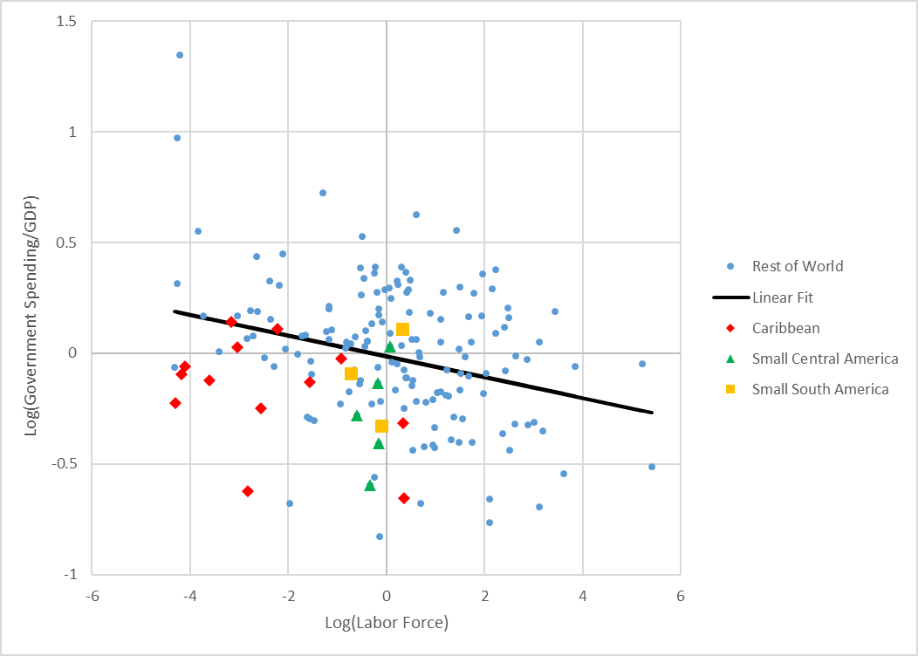

**Notes:** The figure represents the partial correlation between Government Spending over GDP (average 1990-2013) and labor force size (in 2013). It is calculated by first regressing GDP per capita PPP (in 2013) on both government spending and labor force to obtain residuals

Log(government spending/GDP)=log(GDP per capita) + residual

Log(labor force) = log(GDP per capita) + residual

Residuals from these regressions are plotted above. The line represents a linear fit of the data and the relationship between the two variables is significant with a coefficient of -.047 that is significant at the 1% level.

**Source:** Lederman and Lesniak forthcoming, based on data from IMF WEO and World Bank WDI datasets.

## Figure 2: Openness and Labor Force Size

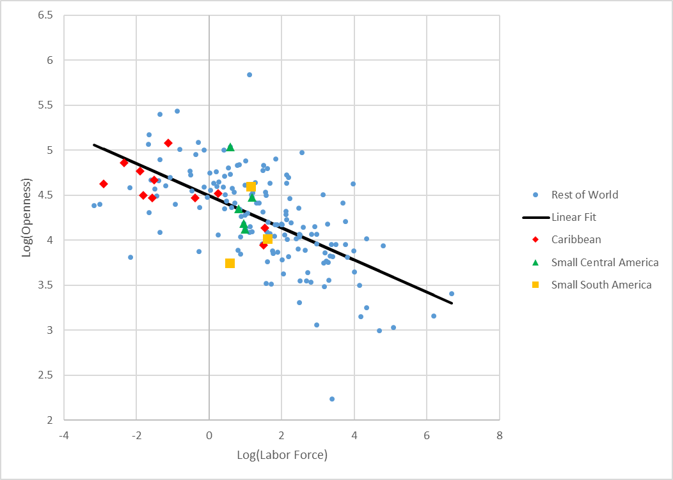

**Notes:** The plot represents the relationship (in logs) between labor force size (in 2013) and Openness (trade/GDP, average 1970-2013). The line represents a linear fit to the data. The relationship between these variables is statistically significant at the 1% level with a coefficient of -0.178.

**Source:** Lederman and Lesniak forthcoming, based on data from World Bank WDI.

## Figure 3: The Number of Export Products and Services and Labor Force Size

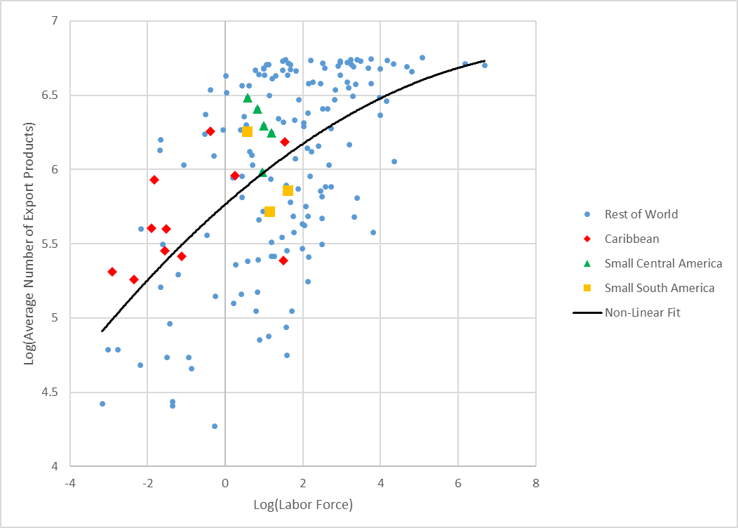

**Notes**: The plot above represents the relationship (in logs) between labor force (in 2013) and average export product lines (over period 1995-2013). Export product lines includes services where data is available. The line represents a polynomial fit to the data. The R-squared is 0.329, which implies that almost one third of the variation in the number of exports is explained by the variation in the size of the labor force across countries.

**Source:** Lederman and Lesniak forthcoming, based on data from Consolidated Dataset on Trade in Services v8.8, World Bank WDI, and UN COMTRADE.

## Figure 4: Partial Correlation between Terms of Trade Volatility and Export Products

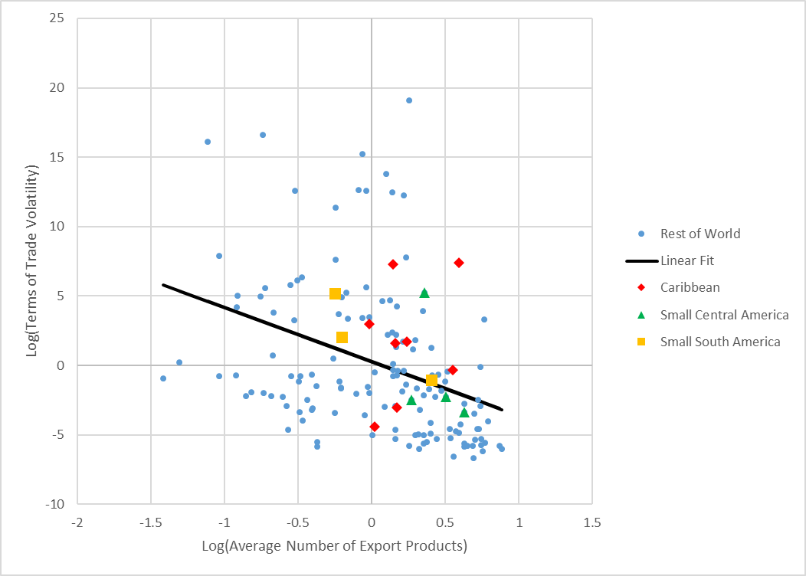

**Notes:** The figure represents the partial correlation between Terms of Trade growth Volatility (calculated over period 1970-2013) and the number of export product lines (average value for 1995-2013). First labor force (in 2013) is regressed on both of these variables to obtain the residuals.

Stdev(terms of trade growth)= log(labor force) + residual

Log(average export product lines)= log(labor force) + residual

Residuals from these regressions are plotted above. The line represents a linear fit of the data and the relationship between the two variables is significant at the 1% level with a coefficient of -3.894.

**Source:** Lederman and Lesniak forthcoming, based on data from Consolidated Dataset on Trade in Services v8.8, Penn World Table v8.1, World Bank WDI, and UN COMTRADE.

## Figure 5: Export-Product Churning across Countries of Different Sizes and Over Time



**Notes**: The 4 plots represent countries grouped by labor force size (in 1995). Moving up the Y axis means creating new products in the current period that were not present in the previous period. Moving to the right on the X axis means that in the current period you are stopping production of more products from the previous period. The red lines represent the global median values of creation and destruction.

**Source:** Lederman, Pienknagura and Rojas (2015), based on data from UN COMTRADE.

.

## Figure 6: Emigration Rates and the Size of the Labor Force

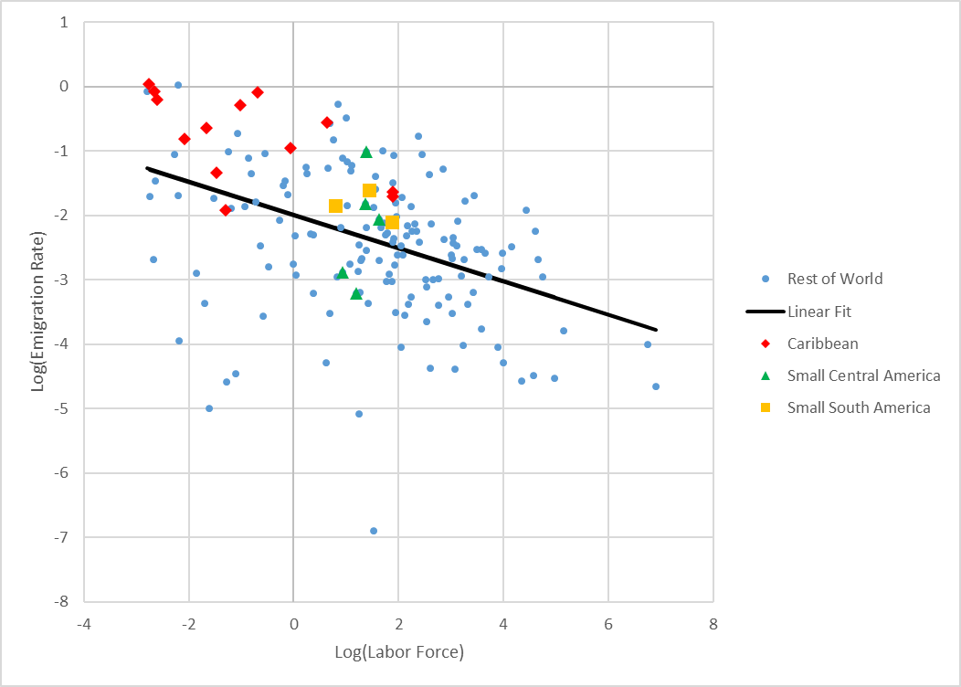

**Notes**: Graph shows the relationship (in logs) between the ratio of stock of emigrants/labor force (2015 values) and the labor force (2015 value). The line shows a linear fit of the data. The relationship between the variables is statistically significant at the 1% level with a coefficient of -0.257. This relationship holds after controlling for (log of) GDP per capita and the long run (1990-2015 average) domestic unemployment rate. That regression yields a coefficient on log(labor force) of -0.296 significant at the 1% level.

**Source**: Calculations based on data from World Bank WDI and United Nations Global Migration Dataset

## Table 1: Determinants of Remittances as a Share of GDP, 1990-2013

|  |  |  |  |  |
| --- | --- | --- | --- | --- |
|  | (1) | (2) | (3) | (4) |
| VARIABLES | Remittances/GDP | Remittances/GDP | Remittances/GDP | Remittances/GDP |
|  |  |  |  |  |
| Labor Force | -0.249*** | -0.251*** | 0.00168 | 0.0315 |
|  | -0.0586 | -0.049 | -0.055 | -0.0597 |
| GDP per Capita |  | -0.559*** | -0.654*** | -0.667*** |
|  |  | -0.114 | -0.107 | -0.106 |
| Emigrants/Population |  |  | 0.800*** | 0.758*** |
|  |  |  | -0.103 | -0.101 |
| Unemployment Rate |  |  |  | 0.425** |
|  |  |  |  | -0.167 |
| Constant | 0.750*** | 5.861*** | 8.187*** | 7.293*** |
|  | -0.154 | -1.051 | -1.044 | -1.023 |
|  |  |  |  |  |
| Observations | 158 | 158 | 158 | 158 |
| R-squared | 0.079 | 0.233 | 0.438 | 0.474 |
| Robust standard errors in parentheses |  |  |  |  |
| *** p<0.01, ** p<0.05, * p<0.1 |  |  |  |  |
|  |  |  |  |  |

**Notes**: Variables are in logs. Labor force and GDP per capita are 2013 values. Remittances/GDP and unemployment rates are averages from 1990-2013.

**Source**: Calculations based on data from World Bank WDI and United Nations Global Migrations Dataset

## Table 2: Determinants of Labor Force Participation, 1990-2013



**Notes**: All variables are in logs. Labor force and GDP per capita are 2013 values. Participation rate and remittances/GDP are 1990-2013.

**Source**: Calculations based on data from World Bank WDI.

1. Ariel Dorfman’s auto-biographical narrative about his bilingual migration from Chile to the United States and back was titled *Heading South, Looking North: A Bilingual Journey* (1998). See <http://arieldorfman.com/>
2. In *Open and Nimble: Finding Stable Growth in the Caribbean* (forthcoming), Justin Lesniak and I use a definition of economic size based on the working age population. Further, we conclude that 5 million workers is a suitable threshold for separating the world into small and large economies, since this is the median size of the workforce around the world in the early 21st Century. Dr. Demas’s definition of 10 million people appeared in his 1966 University of Toronto Press book, *The Economics of Development in Small Countries with Special Reference to the Caribbean*. At the time of writing, his definition would yield basically the same set of countries (or territories) that *Open and Nimble* classifies as being small economies.
3. Emphases on “effective” and “formal” appear in the original text. See page 6, in *West Indian Nationhood and Caribbean Integration: A Collection of Papers*, 1974.
4. William G. Demas served as President of the Caribbean Development Bank during 1974-1988.
5. Yotopoulus (1967, p. 245).
6. See Antweiler and Trefler (2002).
7. See, also, Bown et al. 2016, *Better Neighbors: Towards a Renewal of Economic Integration in Latin America and the Caribbean*. <https://openknowledge.worldbank.org/handle/10986/25736>.
8. On Latin American and Caribbean fiscal policies and their cyclical properties, see Vegh, Lederman and Bennett (2017): <https://openknowledge.worldbank.org/handle/10986/26364>.
9. See Fajnzylber and Lopez (2008).