DRAFT TERMS OF REFERENCE

CONSULTANCY SERVICES FOR ESTABLISHING A CARIBBEAN E-MOBILITY FUND

BACKGROUND

1.01 Caribbean countries remain heavily reliant on imported fossil fuels, exposing them to volatile energy markets and threatening energy security. In response, all Borrowing Member Countries (BMCs) have adopted national strategies to promote Sustainable Energy (SE) and strengthen climate resilience, with targets aligned to their Nationally Determined Contributions (NDCs) under the Paris Agreement.

1.02 Despite growing commitments, progress in Renewable Energy (RE) has lagged, and regional RE penetration remains well below CARICOM’s 2027 milestone. The Caribbean Development Bank (CDB) has therefore launched the Accelerated Sustainable Energy and Resilience Transition 2030 (ASERT-2030) framework under its Energy Sector Policy and Strategy (2022), to help BMCs fast-track RE investments through collective action and strategic partnerships.

1.03 A key pillar of this transition is electric mobility, which offers a transformative opportunity to reduce GHG emissions, enhance energy access, and deliver socioeconomic co-benefits—such as job creation, cost savings, and gender-responsive opportunities in the energy and transport sectors. Transport currently accounts for nearly 40% of fuel use in CARICOM states and 10% of GDP in some economies, making it a high-impact area for climate investment.

1.04 To guide regional efforts, the CARICOM Regional Electric Vehicle Strategy (REVS) was endorsed by Energy Ministers in 2023. Countries such as Barbados, Jamaica, Saint Lucia, and Antigua and Barbuda have begun implementing national EV strategies, supported by policy incentives and pilot initiatives.

1.05 Recognising the need to accelerate investment and overcome barriers, including high upfront costs, limited infrastructure, and constrained public financing—CDB proposes the establishment of a Caribbean E-Mobility Fund. This multi-donor facility will offer technical assistance and blended finance to support policy development, institutional strengthening, private sector participation, and infrastructure deployment for EV adoption—including marine and riverine transport solutions. The Fund will be anchored in CDB’s Strategic Plan, the ASERT-2030 framework, the REVS, the Climate Resilience Strategy, and the SDF 11 Programme. A related discussion paper is attached at Appendix A.

OBJECTIVE

  - The primary objective of this consultancy is to support the Caribbean Development Bank (CDB) in the design, establishment, and capitalisation of a Caribbean E-Mobility Fund. This includes the development of a viable, regionally responsive financing mechanism to catalyse investments in low-carbon transport across Borrowing Member Countries (BMCs). Specifically, the consultant firm will:

- Conduct a market assessment and pre-feasibility study to evaluate the current state, opportunities, and barriers for e-mobility deployment in the Caribbean.

- Prepare a Green Climate Fund E-Mobility Concept Note (using the template provided at Appendix C) that is aligned with national climate strategies of BMCs and justifies the need for GCF financing to scale size of the E-mobility Fund.
- Design a comprehensive fund structure, including operational modalities, eligibility criteria, financing instruments, and governance arrangements.

- Conduct stakeholder consultations and regional outreach to inform fund design and build consensus among public and private sector actors.

- Recommend appropriate institutional and fiduciary arrangements for fund management and oversight, including alignment with CDB systems and international standards; and

- Identify and engage potential donors and development partners (e.g., Green Climate Fund, DFIs, bilateral donors) to support fund capitalisation.

SCOPE OF SERVICES

3.01 The Consulting Firm will be required to deliver a comprehensive set of technical, institutional, and strategic inputs to support the establishment of the Caribbean E-Mobility Fund. The scope of services shall include, but not be limited to, the following:

- E-Mobility Market Assessment and Pre-Feasibility Study

Conduct a comprehensive regional analysis to inform the Fund’s structure and priorities. This will include:

  - Segmentation of the market by vehicle type, application (e.g., public transit, private use, tourism), and customer type.
  - Assessment of current Electric Vehicle (EV) penetration levels and infrastructure across BMCs.
  - Identification of key public and private sector actors and market shares where available.
  - Evaluation of charging infrastructure coverage and electric grid capacity, including rural and remote locations.
  - Estimation of CO₂ emissions reduction potential from transport electrification.

- Comparative Fund Design Review

Review international and regional climate/e-mobility fund models implemented by MDBs, DFIs, and other partners. Identify:

  - Best practices in governance, operations, eligibility, and financial instruments.
  - Lessons learned and their applicability to the Caribbean context.

- Green Climate Fund (GCF) Concept Note

Using the findings of the market assessment and pre-feasibility study, develop an E-mobility GCF Concept Note. The GCF Concept Note should be in accordance with the GCF template and requirements, including:

- A justification for transitioning to electric mobility and its contribution to reducing greenhouse gas emissions.
- The challenges and barriers in the current transport system and identify how e-mobility offers a sustainable, low-carbon solution.
- A set of actions that deliver measurable outputs and outcomes such as reduced emissions, increased adoption of electric vehicles, and improved urban mobility.
- Proposed funding structure (e.g., grants, loans), implementation timeline, and strategies to manage technical, financial, and operational risks.

- Design of the Caribbean E-Mobility Fund

Develop the full structure and scope of the proposed Fund, including:

  - Governance arrangements, institutional roles, and fiduciary options.
  - Eligibility criteria, fund access modalities, and workflow.
  - Gender-responsive and socially inclusive design elements.
  - Monitoring and evaluation (M&E) framework.

- Design of Financial Instruments and De-risking Mechanisms

Recommend appropriate financing tools tailored to the Caribbean market, including:

  - Credit guarantees, matching grants.
  - Blended finance options and incentives to crowd in private capital.
  - De-risking tools for early-stage projects and underserved segments.

- Development of Implementation Toolkit

Prepare supporting tools and materials for Fund operationalisation:

  - Detailed implementation plan with timelines and responsibilities.
  - Operational Manual (including fund flowcharts and decision protocols).
  - Monitoring and evaluation framework.
  - Resource mobilisation strategy and donor engagement roadmap.

- Stakeholder Engagement and Donor Outreach

Lead and support stakeholder engagement activities to validate fund design and build broad-based support:

  - Conduct consultations with national governments, regulators, utilities, private investors, and civil society.
  - Facilitate discussions with prospective funders (e.g., GCF, DFIs).
  - Integrate stakeholder feedback into final deliverables.

4. REPORTING REQUIREMENTS

4.01 The Consulting Firm shall report to the Sustainable Energy Unit (SEU) of the Caribbean Development Bank (CDB) and will be responsible for delivering the following outputs in accordance with the specified timelines:

Key Deliverables and Indicative Timelines

No. | Deliverable | Description | Timeline (from contract start)
1. | Inception Report | Outlines the Consulting Firm’s proposed methodology, detailed work plan, and stakeholder engagement strategy. | By end of Month 1
2. | E-Mobility Market Assessment and Pre-Feasibility Study | Provides a regional analysis of e-mobility market segmentation, penetration levels, infrastructure readiness, and CO₂ mitigation potential. | By end of Month 3
3. | Comparative Fund Design Review Report | Summarises lessons from international e-mobility/climate funds and identifies best practices for Fund design. | By end of Month 4
4. | Green Climate Fund Concept Note | Develop an E-mobility GCF Concept Note for the Caribbean that demonstrates how the project will contribute to climate change mitigation by reducing greenhouse gas emissions through the adoption of electric transport solutions and include a strong rationale for GCF financing. | By end of Month 5
5. | Complete Fund Design Package:  a) Operational Manual  b) Governance Framework  c) Proposed Financial Instruments and De-risking Tools  d) Monitoring and Evaluation Framework | Presents the complete structure, operational modalities, eligibility criteria, governance model, and M&E framework for the Fund and develop operational documents and materials. | By end of Month 6
6. | Promotional and Communications Materials Developed | Includes fact sheets, presentations, and knowledge-sharing content to support stakeholder engagement and donor mobilisation. | By end of Month 7
7. | Final Summary Report and Resource Mobilisation Strategy | Consolidated report including stakeholder feedback, final recommendations, and roadmap for engaging funding partners. | By end of Month 9

Submission and Approval Process

- All deliverables must be submitted in editable electronic formats (Word, Excel, PowerPoint) and PDF.
- Draft versions shall be submitted for CDB review at least two weeks prior to each final submission date.
- Final acceptance of deliverables will be subject to CDB’s written approval, following review and incorporation of feedback within one (1) week.

5. IMPLEMENTATION ARRANGEMENTS

5.01 The Consulting Firm will perform all services remotely. Engagements with CDB staff, regional institutions, and national stakeholders will be conducted via virtual meetings, email correspondence, and other digital collaboration tools. No travel or in-person missions are anticipated under this consultancy, and the assignment is expected to be executed remotely. However, if the Consultant’s proposed methodology demonstrates that limited in-country travel is essential to achieving specific objectives—such as stakeholder consultations that cannot be effectively conducted virtually—such travel may be considered, provided it can be accommodated within the overall budget.

5.02 The Consulting Firm will report to the Sustainable Energy Unit (SEU) Specialist, who will serve as the primary point of contact and provide technical oversight and guidance throughout the assignment.

5.03 All reports, deliverables, and related documentation shall be prepared and submitted in English. Final versions must be delivered in both Microsoft Word and PDF formats.
In addition, the Consulting Firm shall submit all relevant source files (including data sets, financial models, spreadsheets, and presentations) in editable formats, organised using a clear and logical folder structure with descriptive file names, to ensure transparency and facilitate future use by CDB.

ESTIMATED DURATION

6.01 The estimated duration of this project is 9 consecutive calendar months.

7. QUALIFICATIONS AND EXPERIENCE
7.01 The Consulting Firm shall demonstrate a minimum of ten (10) years of relevant experience in the design and operationalisation of climate finance instruments, with a focus on sustainable energy project preparation in developing country context. Specific experience in supporting transport sector transformation projects will be considered as an asset.
7.02 The Consulting Firm must also have demonstrated expertise in conducting stakeholder engagement and communications to inform fund design and the preparation of proposals, including institutional operational frameworks such as guidance manuals, for multilateral climate funds. .
7.03 The Consulting Firm should demonstrate:

- At least two successfully completed assignments of similar scope in the past five years.
- Proven capacity to lead multi-stakeholder consultations and deliver outputs remotely.
- Strong understanding of regional development priorities, e-mobility ecosystems, and climate resilience strategies. Prior experience in the Caribbean region would be considered an asset.
- Organisational capacity to manage a multidisciplinary team and meet tight deadlines.
- Fluency in written and spoken English and excellent communication skills are essential.

7.04 At a minimum, the Consulting Firm’s proposed team shall include the following key experts:

  - Team Leader / Fund Design and Project Preparation Specialist

- A minimum of a Master's degree in finance, public policy, economics, or related field.
- At least 10 years’ experience in climate finance, fund structuring, or infrastructure development in developing country contexts.
- Demonstrated experience designing and operationalising multi-donor funds, preferably with MDBs.
- Proven leadership in managing multidisciplinary teams and engaging donor partners.
- Excellent analytical and report writing skills; fluency in English is required.

- E-Mobility and Sustainable Transport Advisor

- A degree in transport planning, engineering, energy systems, or a related discipline.
- Minimum of 7 years of experience in e-mobility planning, EV infrastructure deployment, or transport energy transition projects.
- Prior work in SIDS or emerging economies is an asset.
- Demonstrated ability to assess technical, economic, and regulatory considerations related to electric mobility.

- Communications and Stakeholder Engagement Specialist

- A minimum of a Bachelor’s degree in communications, public relations, development marketing, or a related field. Relevant professional certifications in digital media or strategic communications is an asset.
- At least 5 years of experience in developing communications strategies, public outreach materials, and stakeholder engagement plans for international development projects.
- Proven ability to prepare user-friendly deliverables for diverse audiences, including donor-facing promotional materials.
- Experience facilitating virtual consultations and engagement activities is essential.

APPENDIX A

DISCUSSION PAPER: CARIBBEAN E-MOBILITY FUND

- INTRODUCTION

  - The Caribbean transport sector is heavily reliant on fossil fuels, contributing significantly to national greenhouse gas (GHG) emissions and exposing countries to the volatility of global fuel markets. The region’s fragmented policies, limited e-mobility infrastructure, constrained financial ecosystems, and insufficient awareness among consumers and financial institutions hinder the transition to a sustainable, low-emission transport future. The Caribbean E-Mobility Fund is being designed to address these systemic barriers by enhancing enabling environments, catalysing investment, and strengthening institutional and human capacity to support the widespread deployment of e-mobility technologies, including electric vehicles (EVs), marine and riverine transportation, and associated technologies and infrastructure across countries in the Caribbean.

Justification/Rationale

  - Transportation, including marine and riverine transportation, plays a crucial role in economic development in the Caribbean but is also the largest consumer of fuel, making it a leading source of greenhouse gas emissions. Fuel imports account for about 10% of GDP in CARICOM Member States, with 39% of total fuel consumption attributed to transportation. This sector is a key target for reducing fuel import dependency, diversifying energy supply, improving transportation efficiency, mitigating GHG emissions, and enhancing the quality of life in the Caribbean. Recognising its impact, most CARICOM Member States have prioritised transportation in their Nationally Determined Contributions (NDCs) (See Figure 1 below). Achieving these NDC targets may be hindered by the high levels of central government debt across the Caribbean and the low levels of private sector investment in climate action across the Caribbean. High levels of government debt limit the government’s fiscal capacity to raise capital and de-risk investments, which when combined with the lack of a clearly defined bankable portfolio of investments, contributes to the limited private sector engagement in climate actions. To this end, technical assistance, tailored blended financing, and partnerships are critical to unlock concessional financing for investments in low-carbon resilient transport infrastructure across the Caribbean.

Figure 1: Selected Transport Sector NDCs Targets in Caribbean
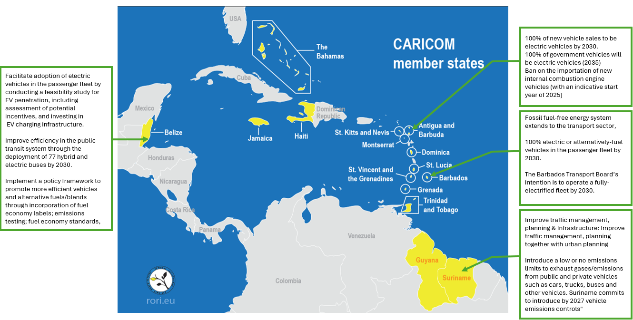
Source: CCREEE (2025)

  - At a regional level Caribbean Community (CARICOM) has developed a Regional Electric Vehicle Strategy (REVS) Framework. The framework provides the building blocks for the electric mobility transition in the Caribbean region and aims to catalyse the deployment of electric vehicles (EVs) across all modes of transportation in the Caribbean, recognising the urgent need for transformative changes in transport systems, mobility preferences, and driving behaviours across the region. In pursuit of a sustainable, efficient, and effective transportation future, the REVS identifies three key disruptors—Electrification, Connectivity through Digitalisation, and Shifting and Managing Transport Demand—as fundamental to the delivery of next-generation transport services.

  - The Caribbean Development Bank (CDB) is supporting transformation towards low-carbon resilient transport sectors in its Borrowing Member Countries (BMCs). The CDB’s Strategic Plan (update 2022-2024 and extension to 2025) places great emphasis on social protection; transformational education; digitalisation; knowledge generation; and economic diversification and private sector development. Further, the CDB’s Climate Resilience Strategy, and the CDB’s Accelerated Sustainable Energy and Resilience Transition (ASERT) 2030 framework ASERT 2030 Framework are key in guiding the bank work towards achieving low-carbon resilient development in the Caribbean. Through its accreditation to the Green Climate Fund (GCF), Adaptation Fund (AF) and engagement the UNFCCC process, the CDB has raised its ambition for mobilising climate finance and is mainstreaming climate resilience measures into its work and across priority sectors such as water, transportation, energy and agriculture.

  - The promotion of E-mobility is a key focus of the CDB’s ASERT 2030 framework. ASERT 2030 is being pursued as a key strategy within the revised Energy Sector Policy and Strategy (ESPS-2022) as a response to the generally slow pace of the transition to sustainable energy (SE) in the Caribbean, In this regard, ASERT 2030 seeks to promote increased speed and scale of investment for SE through transformative collective initiatives among BMCs while ensuring robust engagement and consultation also in the context of Strategic ASERT Partnerships for resourcing and coordination.

Figure 2: EV Penetration within the Caribbean
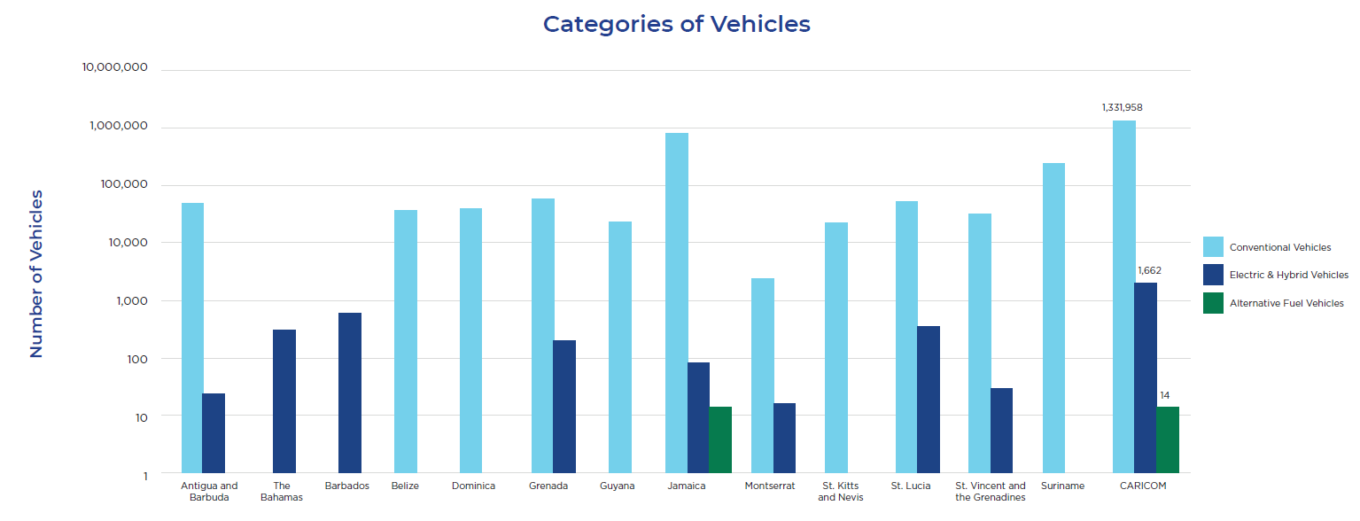
Source: CCREEE (2021). Energy Report Card (ERC)

  - Against this background, establishing a Multi-donor Caribbean E-Mobility Fund is considered critical to accelerating the Caribbean’s transition toward a resilient, low-carbon transport sector. This is aligned with the objectives of the Regional Electric Vehicle Strategy (REVS), CDB’s Strategic Plan, SDF 11 Programme, CDB’s Climate Resilience Strategy, and the ASERT 2030 framework. The Multi-donor Caribbean E-Mobility Fund will provide affordable and accessible financing and play a catalytic role in driving market transformation and stimulating demand for electric vehicles (EVs) and e-mobile marine and riverine transportation across the region. Its strategic objectives include:

- To make e-mobility more accessible to households, fleet operators, and public agencies by reducing the high upfront cost of EVs and charging infrastructure through concessional loans, guarantees, and grants.
- To spur market demand, boast consumer confidence and signals for market growth.
- To support the deployment of EV charging stations, grid upgrades, and renewable-powered charging solutions, addressing critical gaps in the enabling infrastructure needed for widespread EV adoption.
- To assist governments design and implement policies, incentives, and tariff structures that foster investor confidence and support long-term e-mobility planning and penetration.
- To equip local technicians, transport operators, energy providers, and financial institutions with the skills and tools required for a thriving e-mobility ecosystem.
- To raise greater awareness and highlight the environmental and economic benefits of adopting e-mobility and renewable energy technologies.

  - Inter alia, the establishment of a Caribbean E-Mobility Fund will form a critical, innovative and transformative initiative (ASERTive) to help catalyse and scale-up investments in e-mobility by addressing the main barriers

Barriers

  - Despite the recognised potential of e-mobility technologies to significantly reduce greenhouse gas emissions from the transport sector, several structural, financial, and institutional barriers are impeding their widespread adoption across the region. This is a major challenge, as the electrification of the transportation sector holds the potential to radically expedite the energy transition in all CDB BMCs. This, because, on average the liquid fossil fuel imports account for more than 40% of the total fossil fuel imports and in some cases exceeds 50%.

  - Based on a recently completed Feasibility Study for the Funding Proposal, ‘Transforming Finance to Unlock Climate Action in the Caribbean’, which is to be funded, in part, by the GCF, the main barriers to increase adoption of e-mobility technologies in Belize, Jamaica and Saint Lucia are:

- High upfront costs and limited financing options - EVs generally cost more than internal combustion engine (ICE) vehicles, and access to tailored financing solutions (e.g., lease-to-own or concessional loan products) is limited. Most banks perceive EVs as high-risk, unfamiliar assets, resulting in higher interest rates or outright financing ineligibility.

- Insufficient charging infrastructure - Initiatives like the BEL’s EV charging pilot in Belize and private sector-led deployment in Jamaica are underway; however, the network remains sparse, particularly in rural and mountainous areas. In Saint Lucia, limited infrastructure is further challenged by terrain-related range issues.

- Lack of awareness and consumer confidence - There is a “wait-and-see” mentality among consumers, fuelled by low public knowledge of EV benefits, unfamiliarity with technology, and concerns about maintenance, spare parts, and resale value.

- Limited vehicle availability and market representation - Dealerships offer few EV models, most of which are sourced from outside of the Caribbean. This restricts consumer choice and drives up prices.

- Weak policy support and inconsistent incentives - Although Saint Lucia has implemented zero tariffs on EVs and other countries like Belize are discussing policy reforms, fiscal incentives are not always clear, sustained, or comprehensive. In some cases, EVs are still taxed similarly to ICE vehicles.

- High electricity prices and low fuel costs - In markets like Saint Lucia and Belize, high electricity tariffs (USD 0.38–0.40/kWh) and relatively low fuel prices reduce the cost advantage of EVs and extend payback periods beyond investor expectations (e.g., up to 32 years in Saint Lucia).

  - To overcome these barriers and catalyse e-mobility technologies adoption and overcome existing barriers, a multi-pronged strategy is essential. Establishing dedicated E-Mobility financing mechanisms is crucial for accelerating the adoption of electric vehicles (EVs) and e-mobile marine and riverine transportation. By creating national or regional E-Mobility Funds or credit lines for development finance institutions (DFIs), countries can provide affordable and accessible financing options for purchasing electric vehicles (EVs) and e-mobile marine and riverine transportation. This can be achieved through concessional loans, guarantees, or leasing structures, particularly targeting tourism operators, commercial fleets, and urban commuters. Such initiatives can spur demand by reducing upfront costs and improving the business case for private investment in EVs and charging infrastructure. Additionally, local vendors and financiers, like ATL Jamaica, can offer attractive financing packages in partnership with DFIs and commercial banks, further enhancing the accessibility and affordability of EVs.

  - Infrastructure and ecosystem development are equally important for the successful integration of EVs. Public-private partnerships (PPPs) should be encouraged to co-finance the rollout of charging infrastructure, especially in priority corridors and tourism hotspots. Strategic planning should consider terrain and power grid considerations when siting stations and selecting technology, such as fast chargers versus standard chargers. Governments can support this development by adopting comprehensive, long-term incentive frameworks, including tax exemptions on EVs and charging equipment or grants to offset incremental purchase costs, and incentives for utilities and private developers to invest in grid upgrades and charging networks. Public education campaigns are also vital to build consumer trust and confidence in EV technologies, while training for mechanics, technicians, and dealers is necessary to develop local capacity for EV servicing and maintenance. Technical assistance to financial institutions can also de-risk EV lending through market studies, portfolio guarantees, and product design support.

- PROPOSED INTERVENTION

  - The CDB proposes to establish a Caribbean E-Mobility Fund intended to catalyse financing for the Caribbean’s transition to a resilient low-carbon transport sector through strategic investments, the deployment EVs and associated technologies, policy reforms, and capacity building. The E-Mobility Fund will serve as a transformative financing instrument that reduces market entry barriers, mobilises private capital, and creates a self-sustaining momentum for electric mobility adoption across the Caribbean.

  - It is proposed that the Caribbean E-Mobility Fund offers financing related to two pillars of finance: (1) Technical Assistance for creating an enabling environment; and (2) Technological Transformation and Infrastructure Development for E-mobility

Pillar 1: Providing Technical Assistance for creating an enabling environment.

  - The Caribbean E-Mobility Fund will deliver targeted technical assistance to support CARICOM Member States in creating an enabling environment for e-mobility adoption. This includes the development and harmonisation of national e-mobility policies, legal and regulatory frameworks, incentives, and innovative financing mechanisms to drive e-mobility technology deployment. Countries will benefit from tailored e-mobility roadmaps and technical tools such as economic and financial models, business plans, and strategies for fleet management. Guidelines will also be developed for battery disposal, recycling, and repurposing to promote sustainable end-of-life practices and support a circular economy.

  - Caribbean E-Mobility Fund will also support the implementation capacity-building initiatives aimed at developing the human capital and institutional knowledge required to support the transition. This includes training and certification programmes for transport operators, emergency responders, energy service providers, Electric Motor Technicians, and financial institutions. Targeted training for financial institutions will build their capacity to assess EV-related risks and structure suitable financial products for different groups of customers. These efforts will be complemented by public education campaigns to raise awareness about the benefits and safety of EVs, as well as knowledge-sharing events and expos in collaboration with the private sector to promote technology adoption, industry dialogue, and best practices.

  - The indicative list of activities to be funded by the TA programme are:

- Policy Development and Harmonisation including developing and implementing e-mobility policies, incentives, innovative financing mechanisms and legal frameworks.
- Technical Tools and Guidelines including developing economic and financial models, projects/business plans, fleet management strategies, and waste management and battery recycling and disposal guidelines.
- Technical feasibility studies for project development and EV deployments, including environmental, economic, and social impact assessments and EV supply chain analyses.
- Capacity Building including providing training on EV business operations, safety protocols, operations and maintenance, grid integration, and financing.
- Public Engagement and Knowledge Sharing including promoting E-mobility Fund, EVs adaptation and supporting/hosting EV expos in partnership with the private sector.

Pillar 2: Supporting Technological Transformation and Infrastructure Development for E-mobility

  - The Caribbean E-Mobility Fund will facilitate technology deployment across the Caribbean region via three windows of financing. The first modality is the Private Sector Finance and Incentive Programme, which will provide access to affordable financing options through partnerships with development finance institutions, commercial banks, and other financial intermediaries. By offering concessional loans and guarantees, the programme aims to de-risk investments for early adopters and vulnerable user groups such as micro, small and medium size enterprises.

  - The second modality is a Public Sector Transformation Programme, which that focuses on transitioning public sector fleets to electric vehicles. This includes the deployment of electric buses, taxis, and official government vehicles. Caribbean E-Mobility Fund will support this transition through innovative financing structures such as a matching grant scheme and public-private partnerships (PPPs).

  - The third modality is an Infrastructure Deployment Programme, which is critical to creating a supportive charging ecosystem in each country. This modality with allow access for financing to fund the installation of EV charging stations at residential and commercial buildings and transportation hubs, including bus and taxi terminals. In addition, Caribbean E-Mobility Fund will also promote the integration of renewable energy sources to power charging infrastructure and support necessary upgrades to national grid infrastructure to accommodate increased electricity demand.

Figure 3: Proposed Funding Windows of the Caribbean E-Mobility Fund
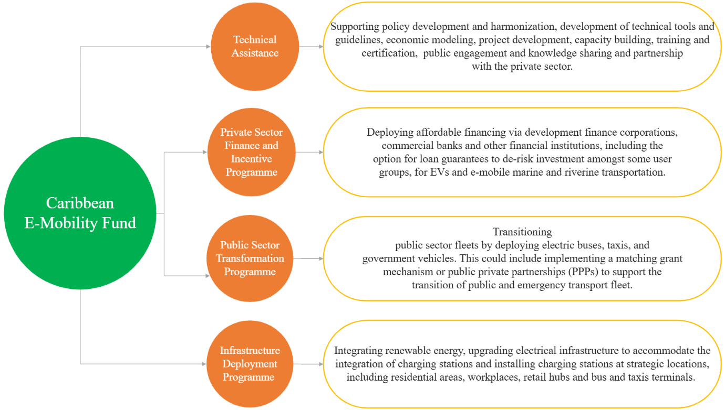
Implementation

  - CDB will administer the Multi-donor Caribbean E-Mobility Fund and spearhead implement of its activities working closely with executing entities in each Borrowing Member Country (BMC). It is not envisioned that the CDB will require new institutional arrangements for the capitalisation and operationalisation of the Fund. Fund raising for capitalisation will be spearheaded by the President’s Office and Strategy, whereas operationalisation will draw on the expertise across the CDB, especially the Project Department working closely with the Finance Division and the Office of the General Counsel.

  - The CDB is currently working closely with Caribbean Centre for Renewable Energy and Energy Efficiency (CCREEE), Deutsche Gesellschaft für Internationale Zusammenarbeit (GIZ), University of the West Indies (UWI), Climate Analytics (CA) and ministries with responsibility for Energy and or Transport in the implementation of project title, “NDC-TEC: Supporting the implementation of NDCs in the Caribbean – transforming the transport and energy sectors towards a low-carbon and climate-resilient future”. This Programme will unearth critical information necessary to support the scale-up and replication of e-mobility initiatives across the Caribbean. The programme has developed and launched a university course on electric vehicle technologies and executed a Training of Trainers course involved over 83 participants from 11 Caribbean countries. The programme is currently executing studies on the end-of-life of EVs, green procurement recommendations, and incentive mechanisms for EVs. Lastly, critical to demonstrate feasibility and fill knowledge gaps related to the different type of e-mobile technologies, applicable to the Caribbean, the programme is piloting investments in Saint Lucia, Jamaica and Grenada. These include: (1) integrating electric vehicles into government fleets in Saint Lucia; (2) electrifying public transport in Jamaica; and (3) exploring the use of electric water transportation for Coast Guard and fishery in Grenada.

  - The Multi-donor Caribbean E-Mobility Fund envisions building on the outputs of this programme as well as the established technical knowledge-base and partnerships established.

Capitalisation of Caribbean E-mobility Fund

  - It is proposed that the Multi-donor Trust Fund is capitalised initially using resources from the CDB’s own resources. These initial injections will be leveraged to crowd-in additional financing from the Green Climate Fund (GCF) and other DFIs, development partners and the private sector. It is envisioned that the financing from GCF and DFIs will flow directly into the Fund; whereas private sector capital could be utilised as matching or cofinancing for the activities to be implemented by the Caribbean E-mobility Fund. It is important to note that the fund is not intended to displace private capital.

  - The Multi-donor Trust Fund will blend sources of financing, enabling the Fund to offer concessional rate that is needed to impactfully de-risk the market and spur greater demand and penetration of e-mobility technologies and infrastructure across the Caribbean.

Figure 4: Potential Funding Sources for Capitalising the Caribbean E-Mobility Fund

- CONCLUSION
3.01 The importation of fuel amounts to approximately 10% of GDP in CARICOM member States. Moreover 39% of total fuel consumption is attributed to transportation. Targeting the transport sector is therefore critical to reduce countries’ reliance on the import of fossil fuels and achieving the ambitious NDC targets set by some CARICOM member States. The Caribbean E-Mobility Fund will support strategic investments, deployment of EVs (and related technologies) and create an enabling environment through policy reforms and capacity building. This Fund is critical to enable the Caribbean’s transition to a resilient, low-carbon transport sector. A mix of funding sources is proposed in order to maximise the level of concessionally needed to de-risk the market, crowd-in private sector investment and ease the burden on government revenue as, notwithstanding some overall improvement in debt sustainability indicators, nearly half of the Bank’s BMCs still have debt to GDP ratios in excess of 60%, with ongoing risks to debt sustainability.

APPENDIX B

SUMMARY OF THE POTENTIAL BENEFITS OF E-MOBILITY FUND

The proposed Caribbean E-Mobility Fund is expected to deliver wide-ranging developmental benefits across environmental, economic, social, and institutional dimensions, contributing meaningfully to the sustainable energy and climate resilience goals of Borrowing Member Countries (BMCs). Key benefits include:

  - Environmental Benefits

- Reduction in greenhouse gas (GHG) emissions from the transport sector, supporting BMCs in achieving their Nationally Determined Contributions (NDCs) under the Paris Agreement.
- Improved urban air quality through decreased vehicular emissions, contributing to public health outcomes.
- Promotion of sustainable end-of-life battery management (e.g., recycling, reuse), advancing circular economy practices in the region.

  - Energy and Climate Resilience Benefits

- Enhanced energy security through reduced dependence on imported petroleum fuels.
- Greater integration of renewable energy (RE) into national grids via green-powered charging infrastructure.
- Contribution to grid stability and long-term energy diversification.

  - Economic and Financial Benefits

- Mobilisation of concessional and blended financing from climate funds and development finance institutions (DFIs), including the Green Climate Fund (GCF).
- De-risking of investments in electric vehicles (EVs) and associated infrastructure, especially for micro, small and medium-sized enterprises (MSMEs).
- Support for local economic development and job creation in emerging sectors such as EV maintenance, charging infrastructure deployment, and fleet operations.

  - Transport Sector Transformation

- Acceleration of EV deployment across public and private fleets, including public transport, government vehicles, and commercial operators.
- Expanded and modernised EV charging infrastructure, including in underserved areas and transport hubs.
- Advancement of digitalisation and data-driven transport planning through integration with EV systems.

  - Institutional and Policy Strengthening

- Support for the development and harmonisation of national EV policies, incentives, and tariff structures.
- Strengthened institutional capacity for e-mobility planning, investment appraisal, and project implementation.
- Alignment with regional initiatives such as the CARICOM Regional Electric Vehicle Strategy (REVS) and CDB’s ASERT-2030 framework.

  - Social and Gender Equity Benefits

- Increased access to safe, affordable, and sustainable transport solutions, particularly for vulnerable and underserved populations.
- Enhanced public awareness of the environmental and economic advantages of e-mobility.
- Opportunities for gender mainstreaming through targeted skills development and inclusive procurement practices.

APPENDIX C

GCF Concept Note Template V3.0

Hereafter EVs is used to refer to all forms of e-mobility technologies including those associated with marine and riverine transportation
Caribbean Centre for Renewable Energy and Energy Efficiency (CCREEE) (2020). The Future of E-Mobility in the Caribbean. Retrieved from: ccreee_brief_future_of_emobility_final.pdf
CARICOM. CARICOM Regional Electric Vehicles Strategy (REVS) Framework. Retrieved from: regional_electric_vehicle_strategy_revs_framework.pdf
Caribbean Development Bank (2024). Draft Transforming Financing to Unlock Climate Action in the Caribbean, Annex 2 Feasibility Study.
NDC-TEC Programme: Promoting climate-friendly transport in the Caribbean - giz.de

