TERMS OF REFERENCE

CONSULTANCY SERVICES TO UPDATE AND EXPAND FLOOD EARLY WARNING SYSTEMS AND CONDUCT TRAINING ON FLOOD EARLY WARNING OPERATION, CONFIGURATION, AND MAINTENANCE

- BACKGROUND

  - From September 2020 through December 2021 the Government of Belize implemented a hydrologic forecast system within the Macal River Basin for the purpose of improving decision support for planning, flood management, and dispatch of hydropower for both near-term (7-day hourly forecasts) and extended (accumulated 45-day) operations. The work was financed under the World Bank Energy Resilience for Climate Adaptation Project (ERCAP) with co-financing provided by the Government of Belize. The project was implemented in close coordination among the Belize National Meteorological Service (NMS), Belize Electricity Limited (BEL), the National Hydrological Service (NHS), and the Belize dam operators, Fortis Belize. Since the completion of the project, the hydrologic forecast system has been running operationally on NMS servers with system accessibility and updates to reservoir operations provided by BEL and Fortis Belize. The system has improved decision support for reservoir operations as well as communication among Belizean stakeholders regarding inflow forecasts and resultant reservoir operations. This project seeks to leverage and build upon the work completed under ERCAP to enhance and expand Belize’s hydrologic forecast system. This includes both system and modelling upgrades as well as enhanced capacity development for stakeholder agencies.

  - The initial hydrologic forecast system developed under the ERCAP project was focused on improving the inflow forecasts for the three primary hydroelectric plants (Chalillo, Mollejon, and Vaca) within the Macal River Basin. This includes ten sub-basins with associated forecasts available for each outlet (see Figure 1 below). Chalillo Dam consists of four upstream sub-basins; Mollejon includes one local sub-basin in addition to upstream releases from Chalillo; Vaca inflows include contributions from two sub-basins as well as releases from Mollejon (see Figure 1); and finally, there are three sub-basins downstream of Vaca to improve flood forecasting warnings for the town of San Ignacio and the Upper Belize River.

  - After an initial review of trade-offs for system and modelling options, stakeholders elected to build the system leveraging the Delft-FEWS platform with legacy United States National Weather Service hydrologic models, i.e., Sacramento Soil Moisture Accounting Model (SAC-SMA), Unit Hydrograph-Generalized (UNIT-HG), and LAG-K. Some primary reasons for this choice included license free software and a history of similar successful forecast systems throughout the world leveraging these same tools.

  - Local data leveraged by the system includes precipitation and river stage station-based data managed by the NMS as well as reservoir pool elevation and flow releases manually reported by Fortis Belize. At the time of development, limited station-based precipitation data within the Macal River Basin existed so the National Aeronautics and Space Administration’s Integrated Multi-satellitE Retrievals for Global Precipitation Measurement (IMERG) product is leveraged for Mean Areal Precipitation (MAP) estimates for each sub-basin.

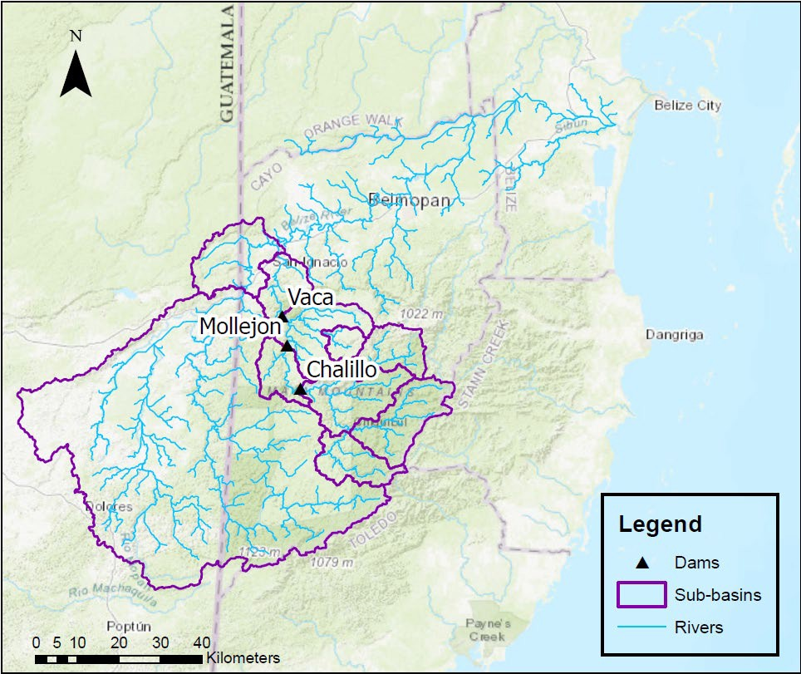
Figure 1. Belize’s hydrologic forecast system dams, sub-basins, and rivers

  - Similarly, current forecast MAP estimates (near-term) are based on the United States National Center for Environmental Prediction’s Global Forecast System. Although the NMS Weather Research Forecast model was also initially implemented as an option for forecast MAPs, issues with running the model locally at NMS limited its use in the hydrologic forecast system and its reinstatement is planned under this project. Long-range (45-day and greater) forecasts leverage climatological ensembles based on retrospective processing of IMERG with the Tropical Rainfall Measuring Mission (TRMM) and TRMM Multi-satellite Precipitation Analysis data set extending back to June 2002.

1.06 In addition to the data analysis, model calibration, and forecast system development work carried out under ERCAP, a hydrometeorological network for the Macal River Basin was also designed to identify the locations of precipitation stations and river gauges within the basin. The installation of these stations has been completed and the incorporation of this new data into the forecast system is planned under this assignment.

  - The three hydroelectrical facilities form an integral part of flood management operations in the overall Belize River and as such improvement in their operations is an important aspect of the early warning system as outline in this Terms of Reference.

  - To finance the exercise described in this Terms of Reference, the Government of Belize has secured funding from the Caribbean Development Bank to undertake the project entitled “Technical Assistance – Implementation of Multi-Hazard Impact-Based Forecast and Early Warning System for the Belize River Watershed”. The project is being implemented between 2025 and 2026 with its expected outcome being improved institutional capacity of NMS and National Emergency Management Organization (NEMO) to deliver effectively early warnings and climate services. Key project outputs will include:

- Current observation network, modelling and analysis tools upgraded.
- Risk analysis and hazard maps developed.
- Reliable and operational forecasting and warning system established.
- NMS and NEMO staff are equipped to effectively manage Early Warning Systems.

- OBJECTIVES

  - The primary objective of this consultancy is to enhance and expand the existing functionality of the hydrologic forecast system while further developing the capacity of Belizean stakeholders. The primary tasks for completion are outlined below with further details provided in the Scope of Work.

    - Expansion of forecast system and modelling to include the entire Belize River Basin.
    - Incorporation of hydrometeorological station data within the Macal and Belize Rivers.
    - Reservoir operations updates.
    - Reestablish NMS local weather prediction model forecasts integration.
    - Coordination of hydrologic forecasts with San Ignacio Flood Inundation Tool.
    - Capacity development of Belize stakeholders through in-person training and extended support.

- SCOPE OF WORK

  - Within the framework of this Terms of Reference, the consulting firm is expected to perform, at a minimum, the tasks described below. Additional considerations from the consultant that may further enhance these minimum requirements are welcome. All responses for each task should describe coordination and project management activities to be carried out.

    - Task 1 – Stocktaking of the current Flood Early Warning System (FEWS)

The Consultant will undertake a review of existing reports and systems, map the make the network of relevant stakeholders and undertake an initial meeting with the key project partners. Based on these early activities, the Consultant will elaborate an Inception Report to more closely guide the remainder of the exercise.

    - Task 2 - Expansion and updating of the system to include modelling and forecasting of the entire Belize River Basin, including:

      - Based on the initial analysis/assessment of the status of the existing FEWS system, undertake remedial actions as necessary to and ensure it is optimally functioning.

      - Update the FEWS configuration with additional sub-basins and station data based on stakeholder needs.
      - Quality control of historic precipitation data and the development of sub-basin mean areal time series.

      - Quality control of historic river stage and flow data; review of existing stage- discharge rating curves.

      - Model calibration (SAC-SMA, UNIT-HG, and LAG-K) of new basins.

      - Ensure that the latest version of FEWS is in use.

      - Update user manual to guide users on how to operate the system based on the added elements.

    - Task 3 - Integration of additional stations in the Macal and Belize Rivers

      - Automatically import precipitation and where available river stage/flow data for approximately 25 stations within the Macal and Belize river from NMS database.

      - Develop preprocessing workflows to ensure quality control of real-time data.

      - Calculate station-based mean areal precipitation time series for use in hydrologic models.

      - Update user manual to guide users on how to operate the system based on the added elements.

    - Task 4 - Reservoir Operations Updates

      - Investigate and develop scripts to import real-time reservoir data from Fortis.

      - Update reservoir modelling simulation based on feedback from Belize Electricity Limited and Fortis Belize.

      - Test and adjust updates to reservoir models in operational system.

      - Update user manual to guide users on how to operate the system based on the added elements.

    - Task 5 - Reestablish NMS local numerical weather prediction (NWP) forecasts integration, such as WRF and ECMWF.

      - Ensure the local NWP forecasts are being ingested by FEWS properly.

      - Test updates and provide guidance on how import processes currently function so that relevant entities may upgrade with potential changes in the future.

      - Update user manual to guide users on how to operate the system based on the added elements.

    - Task 6 - Coordination with San Ignacio Flood Inundation Tool (SIFIT)

      - Initial investigation of leveraging forecast data from FEWS to drive San Ignacio Flood inundation tool during flooding events. With Belize stakeholders, assess and determine whether FEWS will export data sets to SIFIT model to be run separately during floods, or an actual model integration will be pursued within FEWS system.

      - Includes testing model operationally.

      - Develop warning messages when river level thresholds are exceeded.

    - Task 7 - Capacity development through in-person training and extended support

      - Plan and deliver a one-week in-person training on hydrologic forecast system and models to approximately 20 - 30 individuals.

    - Task 8 – Support

      - Ongoing remote support for one year including regular monthly meetings on the system status.

      - On-call system support and debugging (during business hours) for one year.

- REPORTING REQUIREMENTS AND DELIVERABLES

  - Report to Belize NMS – the Consultant will be required to submit electronically the following:

Report/Deliverable | Timeline | Payment schedule
- An Inception Report outlining a detailed work plan and implementation schedule based on the scope of work.  - The report will reflect an initial analysis of the state of play, initial observations based on interaction with stakeholders, updated work schedule and potential challenges foreseen. | Two (2) weeks after the start of the exercise. | 9%
- Report on updated and expanded flood early warning system (FEWS), including hydrologic forecast and accompanying models, inclusive of remaining area of the Belize River Watershed. | No later than three (3) months after start of the exercise. | 20%
- Report on integration of remaining weather stations within Belize River basin into FEWS. | No later than three (3) months after start of the exercise. | 17%
- Report on refined hydrological model and FEWS to include automated updates at all three hydroelectric dams within main tributary of Belize River basin | No later than five (5) months after start of the exercise. | 13%
- Report on integration of NMS local numerical weather prediction (NWP) into FEWS. | No later than five (5) months after start of the exercise. | 7%
- Report integration of FEWS outputs with San Ignacio Flood Inundation Tool and PLUVO and Manual detailing procedures to manage/operate the FEWS.  - The manual is to outline procedures to manage/operate the FEWS. It should also include a section on possible coordination with San Ignacio Flood Inundation Tool and PLUVO. | No later than six (6) months after start of the exercise. | 17%
- Report on in-person capacity development trainings on the updated forecast system and components to be completed over a work week with the Belize NMS and their stakeholders at local offices.  The Report should reflect:  - Learning outcomes and attainment of these by participants.  - Recommendations for additional training.  - List of participants | No later than seven (7) months after start of the exercise. | 7%
- Final updates to hydrologic forecast system manual based on all completed work and approved by key stakeholders. | No later than seven (7) months after start of the exercise. | 9%
- Final Report on exercise and support provided. | No later than seven (7) months after start of the exercise. | 2%

- QUALIFICATIONS AND EXPERIENCE

Firm:

  - Execution of this Terms of References requires a consulting firm having requisite capacities. The successful firm is required to possess the below listed competency for the successful execution of this assignment.

General Experience:

    - Demonstrated experience providing services in early warning systems or a related field for at least 10 years.

Specific Experience:

    - Demonstrated evidence of successfully completing two (2) similar assignments in the past ten (10) years.

    - Evidence of have completed at least two (2) related assigned in the Caribbean or Central America.

Key Experts:

  - Team Leader/Project Lead: The team leader will be responsible for the overall planning, management, and administration of all tasks, coordinating the work simultaneously undertaken by different staff and consolidating the outputs in the expected deliverables.

    - Minimum qualifications: Master’s degree in water resources management, hydrology, civil engineering or a closely related field.

    - Minimum of 5 years of professional experience in an area relevant to this assignment.

    - Proven experience in conducting at least three similar projects, on which at least one should be within the Caribbean/Belize region.

    - The expert should have experience managing at least three similar projects related to hydrologic forecast systems.

    - Extensive management experience working in a variety of countries and projects related to hydrologic forecasting with a preference in familiarity with the Delft-FEWS software.

    - Demonstrated skills in project planning, institutional and capacity development, and stakeholder facilitation, coupled with the technical understanding gained through a career working on hydrologic forecasting systems is essential.

  - Systems Engineer: The systems engineer will be primarily responsible for updating the Delft-FEWS hydrologic forecast system while coordinating with stakeholders and the project team. This will include connecting additional data feeds and modelling zones as outlined in the scope of work.

    - Minimum qualifications: Bachelor’s degree in water resources management, hydrology, civil engineering, software development, computer science, or a closely related field.

    - Minimum of five years of professional of experience in a field related to the assignment.

    - Proven experience in conducting similar projects within the Caribbean/Belize region.

    - The expert should have experience developing Delft-FEWS hydrologic forecast system for three similar projects.

  - Hydrologic Modeler: The hydrologic modeler will be responsible for updating existing hydrologic modelling locations and calibration of models to new locations. The expert will have experience preparing and analysing historical hydrometeorological data for model forcings. The expert will have experience with the United States National Weather Service hydrologic modelling suite inclusive of SAC-SMA, UNIT-HG, and LAG/K models.
    - Minimum qualifications: Bachelor’s degree in water resources management, hydrology, civil engineering.

    - Minimum of three years of professional experience in an area related to the assignment.

    - Proven experience in conducting at least one similar hydrologic modelling tasks as outlined in the scope of work (SOW) and experience calibrating the SAC-SMA, UNIT-HG, and LAG/K models.

  - Reservoir Modeler: The reservoir modeler will be responsible for updating the forecast system reservoir operations per feedback from project stakeholders. The expert should have experience developing reservoir models for real-time operations.

    - Minimum qualification: Bachelor’s in water resources management, hydrology, civil engineering, or a closely related field.

    - Minimum of five years of professional experience in an area related to the assignment.

    - The expert should have proven experience in conducting at least one reservoir modelling task as outlined in the SOW.

- DURATION AND LOCATION

  - The exercise is expected to require approximately 230 working days over the period of 7 months, March 2026 – September 2026.

  - The assignment will be undertaken in Belize and will require travel to the country. The NMS will provide office accommodation, equipment and appropriate administrative support to the Consultant while in the country.

- LANGUAGE

  - All reports and other deliverables produced under this assignment shall be in English.

- ADMINISTRATIVE INFORMATION

8.01 Contracting authority: The contract will be issued by the Ministry of Economic Transformation, Belize, on behalf of the National Meteorological Service.

