BELIZE ELECTRICITY LIMITED
TERMS OF REFERENCE

Feasibility Study:
Substation and Transmission System Optimization for
Dangriga Interconnection and the Belize City Metropolitan Area
Financed by the Caribbean Development Bank

March 2026

1. Background

1.1 Overview
Belize Electricity Limited (BEL) is the national transmission and distribution utility of Belize, serving approximately 101,220 customers and meeting a peak demand of approximately 126 MW (2023). BEL procures electricity through in-country independent power producers (IPPs), a power purchase agreement with Comisión Federal de Electricidad (CFE) of Mexico, and its own emergency backup generation. BEL also operates an isolated distribution system on Caye Caulker, supported by diesel generation with a maximum available capacity of 5.1 MW.
BEL's Transmission and Sub-Transmission Grid operates at three voltage levels—115 kV, 69 kV, and 34.5 kV - which consists of approximately 390 miles of overhead lines and 12 miles of submarine cable. A complete listing of BEL's substations and their characteristics is provided in Section 8. BEL uses ETAP software to model and analyze its transmission and sub-transmission system.
In 2022, BEL engaged Siemens PTI to develop a Least Cost Expansion Plan (LCEP), which produced a 20-year roadmap of recommended generation and transmission additions. Following a five-step evaluation process, Siemens identified a Preferred Portfolio of supply and demand resources, including targeted transmission expansions. The plan was determined to be Least Cost and Least Risk while satisfying BEL's Sustainability, Reliability, Quality of Service, and Resiliency objectives.
In 2020, NEI Electric Power Engineering conducted a Design Wind Speed Study to establish appropriate structural loading criteria for transmission infrastructure, explicitly accounting for climate change. The study recommended the following design wind speeds: 181 mph for exposed island locations, 165 mph for coastal areas, and 145 mph for inland areas.
Also in 2020, BEL engaged WAPCOS (India) to recommend a pilot resilience project for the existing 10L Transmission Line (Westlake to Maskall). WAPCOS recommended replacing a portion of the line with Fibre-Reinforced Polymer (FRP) poles and cross-arms and adopting AAAC "ELGIN" conductor to improve durability and performance under extreme weather conditions.
BEL currently has several ongoing substation and transmission projects that will enhance grid reliability and capacity, including works at Belcogen, Bapcol, Caye Caulker, and Ambergris Caye. A full listing of these projects and their expected commissioning dates is provided in Section 8.

1.2 Wider Belize City Metropolitan Area
Belize City and its surrounding metropolitan area are currently supplied by three main substations: Belize City (115/6.6 kV), Westlake (115/22 kV), and Ladyville (22 kV). Two additional 22/6.6 kV substations, Banak and Pallotti (each rated at 14 MVA), provide limited transfer capability, allowing 6.6 kV load to be shifted to the 22 kV system supplied from Westlake and partially serving Ladyville load in the event of a 22 kV line trip.
The center of load is currently concentrated near Belize City, with a 22 kV area northwest of the city served by a rural feeder from Westlake. Growth in the metropolitan area is occurring primarily at the 22 kV voltage level, with negligible new growth at 6.6 kV. Load on the outskirts of Belize City is presently growing at approximately 8.3% per year, and as of 2024 represents approximately 7 MVA.
The current network configuration, in which a 22 kV Switching Station was installed at Ladyville in 1995, was originally justified by the short distance (approximately 5 miles) between the Westlake 115 kV Substation and the Ladyville compound.
A change of circumstances now requires this arrangement to be revised. The Phillip Goldson International Airport (PGIA) has announced plans to upgrade and extend its runway and terminal facilities, which will require the relocation of the existing 22 kV Switching Station at Ladyville.
The current configuration presents several reliability and capacity concerns:
- Single 115 kV supply to Belize City: A fault on the single transmission line from Westlake would cause a complete outage to Belize, the country's largest metropolitan area.
- Overloaded 115/22 kV transformer at Westlake: The combined coincident peak of the Westlake feeder (WST-F1, approximately 7.2 MW) and the Ladyville feeders (LDV-F1 to F3, approximately 9.6 MW) totals approximately 16.8 MW, which exceeds the normal rating of the existing 15 MVA transformer.
- Radial 22 kV circuit to Ladyville: There is no alternate supply. A fault on this circuit would cause a complete outage to the Ladyville area.
- Potential overload at Belize City 115/6.6 kV: If future metropolitan growth were served solely through this substation, the resulting peak load of approximately 20.2 MVA would exceed the normal rating of the single existing 20 MVA transformer.

1.3 Second Supply to Dangriga
The existing 62L 69 kV transmission line was commissioned in 1998. This 39-mile line traverses coastal terrain along the Coastal Road and interconnects the central part of the country at La Democracia (via a 115/69 kV substation) with the Mullins River (69/22 kV tap) and Dangriga (69/22 kV) substations, supplying the southern region of Belize.
The 62L line has a history of poor reliability. Although the network was energized at 69 kV, the original insulation was designed for 34.5 kV operation (with a flashover voltage determined to be approximately 46 kV). Combined with the absence of an overhead shield wire for lightning protection and limited deployment of surge arresters, the line is highly susceptible to lightning-induced outages.
In line with growing demand and the recommendations of the LCEP, a new 115 kV transmission line is required to supply Dangriga and strengthen the southern grid. The current 69 kV transmission network in the south (Lines 60L, 61L, and 62L) operates radially, with no redundancy and only a single generation source (excluding a small run-of-river hydro plant) in the southern link. A new 115 kV line will be essential to support the anticipated increase in southern generation capacity, including a planned new RICE (Reciprocating Internal Combustion Engine) power plant and associated battery energy storage system, as recommended by the LCEP.
LCEP Reference | The Siemens PTI Least Cost Expansion Plan (2022) identifies the new Dangriga 115 kV transmission line as a priority capital project, necessary to support both load growth and new generation integration in the southern region.

2. Objectives
The primary objective of this assignment is to conduct two independent but similar feasibility studies and produce three separate reports for each study; a techno-economic feasibility study, an Environmental and Social Impact Assessment (ESIA), and a Climate Risk and Vulnerability Assessment (CRVA). This suite of reports will demonstrate to a financing institution that the proposed solutions are technically, environmentally, and economically sound.
All work shall be carried out in accordance with the Caribbean Development Bank's Procurement Procedures (January 2021), including provisions on Prohibited Practices (fraud, corruption, collusion, coercion and obstruction).
The two independent studies will identify the optimal engineering solutions for supplying power to the following areas:
- The Belize Southern Grid via the Dangriga Substation
- Wider Belize City Metropolitan Area (Belize City, Ladyville, and Westlake substations)

Secondary Objective: For each study area, complete the engineering design to approximately 10% definition, including selection of a preferred route or site, assessment of project risks, and preparation of a risk-based cost estimate (Class 3) and project schedule.
Tertiary Objective: Produce a preliminary engineering design of sufficient quality to serve as the basis for the subsequent detailed design phase, minimizing rework and abortive effort.
The Consultant shall review the LCEP recommendations as a guiding framework but is expected to independently verify those findings and identify the optimal substation and transmission configuration for each study area.
Each final report shall provide a comprehensive analysis of the Technical, Operational, Maintainability, Environmental, Social, Economic, and Financial elements of the respective project, evaluated over the full asset life cycle. The analysis shall examine feasible route options, conductor types, structure types, and substation configurations using a life cycle cost basis. Specific analytical outputs shall include a Cost-Benefit Analysis, Return on Investment analysis, Level 2 Schedule, cost escalation estimate, Base Cost Estimate, and a quantified Risk Assessment to establish project contingency.
To actively guide and inform the selection of the preferred route, preliminary environmental and climate vulnerability evaluations must commence prior to the completion of the techno-economic feasibility study. Following the selection of the preferred option, that option shall be defined in sufficient detail to feed directly into the final, separate CRVA and ESIA for each respective study area. Each ESIA shall document the status of environmental constraints associated with the selected route and provide an assessment of environmental impacts together with proposed mitigation and monitoring requirements.
As a final output, the Consultant shall also produce technical specifications and a Front End Engineering Design (FEED) document to a level of detail sufficient to form the basis for a request for bids for all major transmission line and substation equipment.

2.1 Procurement Framework and Guidelines

The procurement of consultancy services for this project will be conducted in strict accordance with the Caribbean Development Bank’s Procurement Procedures for Projects Financed by CDB.
Selection Method: Quality and Cost-Based Selection (QCBS)
The Consultant for this assignment will be selected using the Quality and Cost-Based Selection (QCBS) method. This process is used to ensure the highest quality of technical expertise while maintaining price competitiveness.
Overview of the QCBS Process:
- Two-Envelope System: Consultants must submit technical and financial proposals in separate, sealed envelopes.
- Technical Evaluation: The Technical Proposals are opened first and evaluated based on the criteria specified in the Request for Proposals (RFP). Only those firms achieving the minimum qualifying technical score will proceed to the next stage.
- Public Financial Opening: The Financial Proposals of the technically qualified firms are opened publicly at a date and time notified by BEL. Firms that do not meet the technical threshold will have their financial proposals returned unopened.
- Combined Score: The final selection is based on a weighted combination of the technical score (80%) and the financial score (20%). The firm with the highest combined score will be invited for contract negotiations.

3. Methodology
The Consultant shall propose a detailed Methodology in its submission, which BEL will review and must formally accept before work commences. The proposed Methodology shall include the following elements at a minimum:
- A preliminary Work Plan with a budget estimate for each major activity
- A description of key deliverables and the method of analysis to be applied
- A milestone schedule with clearly identified critical path items
- A description of devices, tools, and software that will be used to fulfil the TOR requirements

The Consultant's Methodology shall be reviewed and may be refined at the Inception stage, in agreement with BEL, to reflect actual data availability and site conditions encountered during mobilization.

4. Scope of Services

4.1 Work Plan
Within 15 business days of contract award, the Consultant shall submit a detailed Work Plan that expands upon the preliminary Work Plan included in the proposal. The Work Plan shall address each of the following elements:
- Scope of Work: Specify all tasks and deliverables the Consultant will perform and produce. Clearly identify tasks that require BEL input or data and the anticipated lead time for such inputs.
- Methodology: Describe the approach and analytical techniques to be applied, including: (i) literature review of relevant source data and documents; (ii) collection and analysis of technical, environmental, social, and economic data; (iii) power system modelling approach; and (iv) evaluation of alternatives using a Multi-Criteria Decision Analysis (MCDA) framework that incorporates technical, environmental, social, economic, and resilience factors.
- Resources: Identify the personnel responsible for each key activity, together with the equipment, tools, and estimated budget hours per deliverable.
- Schedule: Provide a milestone schedule with clear deadlines and responsibilities for each task, identify the critical path, and describe the process for updating and maintaining the schedule throughout the assignment.
- Quality Control: Describe the standards, review protocols, and quality criteria the Consultant will apply to ensure the accuracy and completeness of all work, including data validation, internal reviews, and peer review procedures.
- Environmental and Social Assessment Plan: Outline the approach to conducting the ESIA consistent with the requirements of Section 4.5, including the process for walkover surveys and stakeholder consultation.
- Risk Management Plan: Identify the principal risks and uncertainties that could affect the Consultant’s work during the assignment, presented in a tabular risk register format, together with proposed mitigation or contingency measures.
- Reporting: Define the frequency and format of progress reports to be submitted to BEL’s Project Manager throughout the assignment.

4.2 Design Basis
Within 30 business days of commencing services, the Consultant shall prepare a Design Basis Document (DBD) covering both the transmission line and substation components of the project. The DBD is a controlling document for the assignment and shall establish the technical and functional requirements to be applied throughout the feasibility study, including:
- Applicable design standards, codes, and specifications
- Design criteria and key assumptions
- Methodology and tools for calculations and modelling

BEL designs its transmission lines and substations in accordance with RUS (Rural Utilities Service) standards, specifically RUS Bulletin 1724E-300 (Design Guide for Rural Substations) and RUS Bulletin 1724E-200 (Design Guide for Rural Electric Overhead Distribution Lines), which govern horizontal and vertical clearance requirements. The Consultant shall incorporate these standards into the Design Basis and shall additionally verify that all proposed clearances meet or exceed the requirements of the current edition of the US National Electrical Safety Code (NESC).

4.3 Technical Feasibility Assessment
The Consultant shall assess the technical requirements of the proposed solutions and identify any specialized material, software, hardware or other technologies needed to meet those requirements.

4.3.1 Electrical Studies
Load Flow Studies
The Consultant shall conduct load flow studies to evaluate the power transfer requirements and voltage profiles across the transmission network under the following scenarios:
- Study years: 2026 (near-term) and 2036 (long-term planning horizon)
- Demand scenarios: Base Case and High-Demand Load Projection
- Operating conditions: Peak Demand and Minimum Demand critical points
- Network analysis: Full constraint analysis covering load flows, voltage stability, system reserves, and transfer capability
Short Circuit Studies
The Consultant shall conduct short circuit studies using the generation dispatch scenario that produces the highest fault levels on the network. The analysis shall also include a sensitivity comparison across alternative generation mix scenarios to bound the range of fault currents and inform equipment ratings.
System Stability and Reliability Analysis
Using a deterministic (N-1) methodology, the Consultant shall evaluate the future reliability and stability performance of the network with the new and upgraded transmission lines and substations in service. The analysis shall incorporate fault statistics and historical weather data to assess reliability performance indicators.
Optimization Studies
The Consultant shall conduct feasibility-level optimization studies to select the optimal configuration for the following transmission line and substation parameters:
- Conductor size and type (including ACSR, AAAC, and ACCC alternatives)
- Optical Ground Wire (OPGW) specification
- Insulator ratings (Basic Insulation Level, creepage distance, and contamination class)
- Transformer capacity and impedance
- Substation configuration (breaker arrangement and busbar scheme)
- Substation location and operating voltage level

4.3.2 Design Evaluation
Route and Site Selection
The Consultant shall evaluate multiple route and site options, applying the following criteria:
- Safety during construction and ongoing operation
- Ease of access and constructability using standard construction techniques
- Maintenance requirements and long-term operational practicality
- Right-of-Way (RoW) constraints and land ownership considerations
- Minimization of impacts on the natural environment, wetlands, and communities
- Geographical features, including river crossings, coastal zones, and terrain variability
- Overall cost minimization

The Consultant shall produce route alignment drawings at an appropriate scale, clearly identifying affected properties, occupied structures, environmental areas of concern (wetlands, protected areas, water bodies), and other relevant features along each candidate route.
Structure and Line Design Optimization
The Consultant shall optimize the transmission line and substation design at a feasibility level of detail, evaluating the following parameters:
- Structure type: Wood, Concrete, FRP, Steel Pole, or Lattice Tower
- Structure configuration: Staggered, Horizontal, or Delta phase arrangement
- Wind span and weight span
- Conductor size and type
- Overhead versus underground cable options (where applicable)
- OPGW versus conventional shield wire
- Vertical clearances to ground and to crossed facilities
- Substation structure configuration
- Substation primary equipment selection
- Operating voltage level
- Insulation type and level

Foundation Design
The Consultant shall examine route options with a view to minimizing the use of wetlands and areas of poor bearing capacity in order to reduce foundation and anchor costs. Preliminary foundation designs shall be developed for pole structures across the range of soil types anticipated along each candidate route. Foundation and anchor designs shall account for the reduction in soil strength under saturated conditions during hurricane and wet season events, ensuring that structures remain stable under design wind loading conditions.
Lightning Protection Design
The Consultant shall verify the isokeraunic level applicable to the project area, as referenced in Section 8.3 of this TOR, and shall design the overhead shield wire system, mid-span offset, and pole grounding system to achieve a target lightning flashover rate not exceeding 1 flashover per 100 circuit-miles per year.

4.4 Economic Feasibility Assessment

Cost Estimate
The Consultant shall prepare a risk-based capital cost estimate—incorporating both physical and price contingencies—covering the design, procurement, construction, and commissioning of the transmission line and substation works. The estimate shall be based on the preferred option identified through the electrical and design evaluations, with prices benchmarked against comparable recent projects and validated by the Consultant. The estimate shall include, at a minimum, the following components:
- Materials (transmission line hardware, conductor, ground wire, substation equipment, civil works materials)
- Construction works
- Operation and Maintenance (O&M) costs over the project life
- Physical contingency
- Price contingency (escalation)
- Engineering design fees
- Construction supervision and inspection
- Project management
- Testing and commissioning
- Environmental mitigation and monitoring measures
- Land acquisition, easements, and RoW compensation
The Consultant shall present the cost estimate as both a summary and a detailed breakdown by work package. It shall also be converted into a monthly and annual cash flow aligned with the project schedule, separately identifying construction costs and BEL's internal costs, including financing charges.

Economic and Financial Analysis
The economic and financial analysis shall be conducted over the full useful life of the project (typically 30–40 years for transmission assets). The Consultant shall apply any or all of the following methods, as appropriate:
- Financial Internal Rate of Return (FIRR)
- Financial Net Present Value (FNPV)
- Economic Internal Rate of Return (EIRR)
- Economic Net Present Value (ENPV)
- Payback Period
A cost-benefit assessment shall be undertaken, quantifying benefits such as: reduced transmission losses, improved system reliability (expressed in terms of avoided outage costs and improved SAIDI/SAIFI indices), enhanced N-1 security, increased capacity headroom, and facilitation of new renewable generation integration.
The Consultant shall also identify and evaluate financing options, including International Financial Institutions (IFIs), bilateral development agencies, and grant programs relevant to energy infrastructure in the Caribbean. A market study shall be conducted to determine prevailing and projected interest rates applicable to this type of project.

4.5 Environmental Considerations

Permitting and Regulatory Compliance
The Consultant shall identify all environmental permits and regulatory approvals required for the project under Belize national law, including the Environmental Protection Act (Cap. 328), the Physical Planning Act, and any applicable protected area legislation. The review shall determine the project’s compliance obligations and establish the permitting pathway and timeline, which shall be incorporated into the project schedule.

Environmental and Social Impact Assessment (ESIA)
An Environmental and Social Impact Assessment (ESIA) shall be prepared in accordance with Belize's Department of the Environment requirements and CDB's Environmental and Social Review Procedures. Two separate ESIAs shall be prepared to appraise the potential environmental and social impacts of the proposed transmission network upgrades, with specific focus on:
- The new transmission line route for Dangriga
- The new transmission line route for Belize City Metropolitan Area

The ESIA processes shall commence prior to the completion of the feasibility assessment to actively help guide route selection. Once the preferred route option is selected, the respective ESIA shall focus on and be aligned with that specific route and shall include walkover land surveys of the preferred route to confirm the current state of the environment.
The ESIA shall cover the following, at a minimum:
- Baseline environmental conditions: flora, fauna, soils, wetlands, water bodies, terrestrial habitats, and visual/scenic values
- Identification and assessment of potential construction and operational environmental impacts
- Identification and assessment of all social and community impacts, including land acquisition, resettlement, and stakeholder consultations, strictly in accordance with the requirements detailed in Section 4.6.
- Impacts on protected areas, cultural heritage sites, and archaeological resources
- Proposed mitigation measures for all significant impacts
- Environmental monitoring and management plan
- Cost estimates for all mitigation and monitoring measures, to be incorporated into the overall project Cost Estimate

4.6 Social and Community Considerations
The Consultant shall identify and assess potential social impacts associated with the project, including but not limited to: land acquisition and involuntary resettlement, impacts on cultural heritage and archaeological sites, effects on vulnerable and indigenous groups, and public safety risks during construction and operation.
Community and stakeholder consultations shall be conducted in accordance with CDB's Operational Policy on Prohibited Practices and relevant national legislation. Consultations shall be documented and their outcomes reflected in the feasibility report. The Consultant shall propose measures to address identified social concerns, including compensatory frameworks, community engagement programs, local employment and procurement opportunities, and a Grievance Redress Mechanism (GRM).
Site surveys shall be conducted to assess all candidate routes, including the recording of GPS coordinates for transmission line structures and the identification of space requirements for substation expansion. The costs of land acquisition, easements, community engagement, and social mitigation measures shall be included in the project Cost Estimate.

4.7 Risk Analysis
The Consultant shall conduct the risk analysis in the following sequential steps:
- Risk Identification: Undertake a comprehensive review of potential project risks, drawing on consultation with internal and external stakeholders, regulatory bodies, and local communities, as well as a review of risks encountered on comparable recent projects. Risks shall encompass technical, commercial, environmental, social, financial, and schedule dimensions.
- Risk Assessment: Evaluate the likelihood and consequence of each identified risk using a project-specific 5×5 risk matrix. Risks shall be prioritized by severity to focus risk management effort on the most critical items.
- Risk Mitigation: For each high-priority risk, propose proactive mitigation strategies and, where appropriate, alternative design or procurement approaches that reduce risk exposure and improve the probability of project success.
- Risk Quantification: Apply the Expected Value Method to the highest-ranking risks to establish a justified project contingency, which shall be incorporated into the Cost Estimate.
- Risk Monitoring and Management: Define a framework for ongoing risk monitoring throughout the feasibility phase, including threshold triggers for escalation and corrective action. Risk status shall be reported to BEL in a timely manner throughout the assignment.
- Climate Risk and Vulnerability Assessment (CRVA): Conduct two separate, full Climate Risk and Vulnerability Assessments (CRVA) for the Dangriga and Belize City study areas. The CRVA processes must be initiated early to help guide route selection, before finalizing the assessment on the definitively selected routes. The CRVAs shall identify climate risks, necessary design adaptations, and any data gaps that must be addressed to ensure asset resilience.

5. Project Schedule
The indicative schedule proposed by BEL is set out in the table below. Business days are counted cumulatively from the date of the Notice to Proceed (NTP) / Contract Signing, except where noted. The Consultant shall review this schedule as part of its submission and identify any challenges or proposed modifications, providing a revised schedule if the BEL schedule cannot be met. The estimated task durations shown are for one study. However, both studies are to be conducted concurrently or otherwise be completed within the cumulative time noted below.
Deliverable / Phase | Task Duration (Business Days) | Cumulative Timeline (Weeks from NTP)
General Milestones
NTP / Contract Signing | 5 | Week 1
Inception Report with Work Plan and Schedule | 10 | Week 3
Internal Review | 10 | Week 5
Design Basis Report | 15 | Week 8
Preferred Route Selection & Internal Review | 15 | Week 10
Feasibility Study
Draft Feasibility Study Reports | 30 | Week 14
Internal Review | 10 | Week 16
Final Feasibility Study Reports | 15 | Week 18
Internal Review | 10 | Week 20
Climate Risk and Vulnerability Assessment (CRVA)
Draft CRVA Reports | 60 | Week 16
Internal Review | 10 | Week 18
Final CRVA Reports | 15 | Week 19
Internal Review | 10 | Week 20
Environmental and Social Impact Assessment (ESIA)
Site Surveys | 15 | Week 10
Draft ESIA Reports | 20 | Week 14
Internal Review | 10 | Week 16
Final ESIA Reports | 20 | Week 18
Internal Review | 10 | Week 20
Front End Engineering Design (FEED)
Draft FEED Document | 15 | Week 21
Internal Review | 10 | Week 23
Final FEED Documents | 10 | Week 25

Key Milestones | BEL approval of the preferred routes by Week 10 is critical to properly focus the subsequent studies. Additionally, all Draft Reports (Feasibility, ESIA, and CRVA) must be issued by Week 16.

*Note some tasks will be executed concurrently with other active deliverables.

6. Documentation and Reporting

6.1 Reporting
The Consultant shall report to BEL's designated Project Manager for the duration of the assignment. Monthly progress reports shall be submitted in writing, summarizing work completed during the reporting period, work planned for the forthcoming period, any issues or risks encountered, and the current status of deliverables against the agreed schedule.

6.2 Deliverables
All documents shall be submitted in digital format (Microsoft Word and PDF) only. Engineering Drawings are to be submitted in PDF and CAD format. The deliverables listed should be submitted separately for each of the two studies being undertaken.

Inception Report with Work Plan and Schedule
The Inception Report shall present the Consultant’s detailed work plan, methodology, objectives, and an assessment of available information. It shall identify any expected challenges in implementing the study and propose any modifications to the scope or approach deemed necessary to ensure study success.

Design Basis Document
This controlling document shall set out the technical and functional requirements, design standards, codes, assumptions, and calculation methodologies to be applied throughout the feasibility study.

Draft Feasibility Study Report
The Draft Feasibility Study Report shall conform to accepted international standards for infrastructure feasibility studies. It shall constitute a fully bankable document, encompassing the complete technical characterization of the project at feasibility level, together with the results of all economic and financial assessments.

Final Feasibility Study Report
Due 25 business days after BEL’s internal review of the Draft. The Final Report shall incorporate all BEL review comments, shall be free of technical, grammatical, and formatting errors, and shall represent the definitive bankable feasibility study for financing purposes.

Front End Engineering Design (FEED)
The FEED document, as used in the Feasibility Report, shall be submitted as a standalone documents for ease of access by BEL and prospective financiers. The FEED shall include finalized design basis documentation and detailed technical specifications for all major transmission line and substation equipment to a level of detail sufficient to support a request for bids for both equipment procurement and construction works. Furthermore, each FEED must include a comprehensive set of preliminary engineering drawings, encompassing Single Line Diagrams (SLDs) and General Arrangement (GA) drawings for the proposed substations and transmission infrastructure.

Cost Estimate
The Cost Estimate used in the Feasibility Report shall be submitted as a standalone document (Microsoft Excel and PDF) to facilitate review, updating, and use in financing applications. These estimates shall be developed to the standard of a Class 3 engineering cost estimate (such as AACE International guidelines), providing a level of accuracy and risk quantification suitable for project funding authorization and baseline budgeting.

Environmental and Social Impact Assessment Report
The ESIA report shall be submitted, covering the selected preferred routes and grid expansion for Transmission Line to Dangriga Substation and the Belize City Metropolitan Area respectively. These reports must be prepared in accordance with the environmental and social safeguard requirements of Belize's Department of the Environment (DOE) and the Caribbean Development Bank (CDB). They shall include: a description of the applicable policy and regulatory framework; an assessment of environmental and social constraints along the preferred routes; an evaluation of construction and operational environmental and social impacts; proposed mitigation measures; and an environmental and social monitoring and management plan.

Climate Risk and Vulnerability Assessment (CRVA) Report
The CRVA report shall include all mapping, calculations, methodologies, and results. It shall present recommendations for the design options to be taken forward and incorporated into the project design, ensuring that the transmission assets are resilient to projected climate change conditions over their operational life.

7. Qualifications of the Consultant
The Consultant shall demonstrate a minimum of five (5) years of organizational experience delivering feasibility studies, engineering designs, and environmental assessments for high-voltage transmission and substation projects of comparable scope and complexity. Demonstrated experience working in developing countries with similar climatic, geographic, and regulatory conditions will be regarded as a significant advantage.
All proposals shall include: evidence of relevant organizational qualifications and project experience; curricula vitae of proposed key personnel; and client references with contact details for a minimum of three comparable projects.
Excellent written and spoken English is essential for all key personnel. The Consultant team shall include, at a minimum, professionals with the following areas of expertise and certification:

Discipline / Role | Minimum Qualifications & Experience
Lead Power Systems Engineer | Licensed professional engineer with ≥10 years of experience in transmission and substation design; proficiency in power system modelling tools (e.g., ETAP, PSS/E, or equivalent); experience with load flow, short circuit, and stability studies.
Substation / Protection Engineer | ≥7 years of experience in HV substation design (115 kV and above); familiarity with RUS bulletin standards and IEC/IEEE protection schemes.
Transmission Line Engineer | ≥7 years of experience in overhead transmission line design; knowledge of NESC clearance requirements, structure loading, and foundation design in tropical/coastal environments.
Environmental Specialist | Degree in environmental science, ecology, or related field; ≥5 years of ESIA experience in the Caribbean or similar developing-country context; familiarity with Belize's Environmental Protection Act and CDB environmental and social safeguards.
Cost Estimating Specialist | ≥7 years of experience preparing Class 3 or better capital cost estimates for transmission and substation projects; proficiency in risk-based estimating and contingency determination.
Economist / Financial Analyst | ≥5 years of experience conducting FIRR/EIRR analyses for infrastructure projects, preferably with IFI-financed projects (CDB, IDB, World Bank).
Climate & Risk Specialist | Experience conducting Climate Risk and Vulnerability Assessments (CRVA) for energy infrastructure in the Caribbean region.

8. Attachments

8.1 Route Map
Existing La Democracia to Dangriga 69 kV Line Route

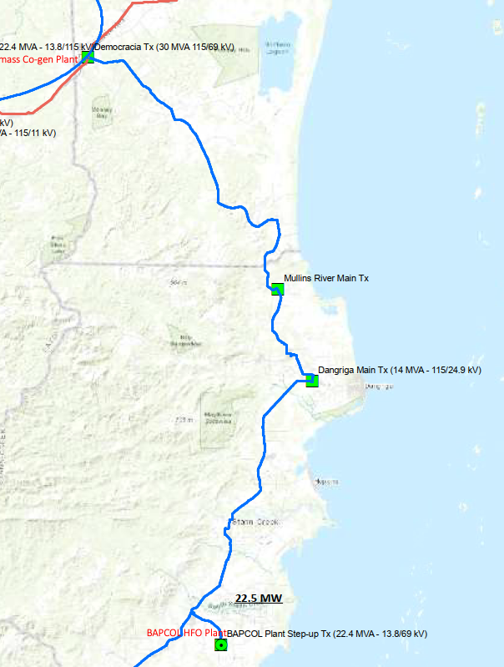

8.2 Grid Characteristics
BEL’s Transmission and Sub-Transmission Grid traverses Belize at multiple voltage levels, with a total overhead line length of 398.91 circuit-miles distributed as follows:
- 115 kV lines: 200.64 miles — 100-foot right-of-way
- 69 kV lines: 135.45 miles — 60-foot right-of-way
- 34.5 kV lines: 48.74 miles — 50-foot right-of-way
- 22 kV lines: 14.08 miles — 50-foot right-of-way

Detailed listings of transmission and sub-transmission lines, and existing substation transformer characteristics.
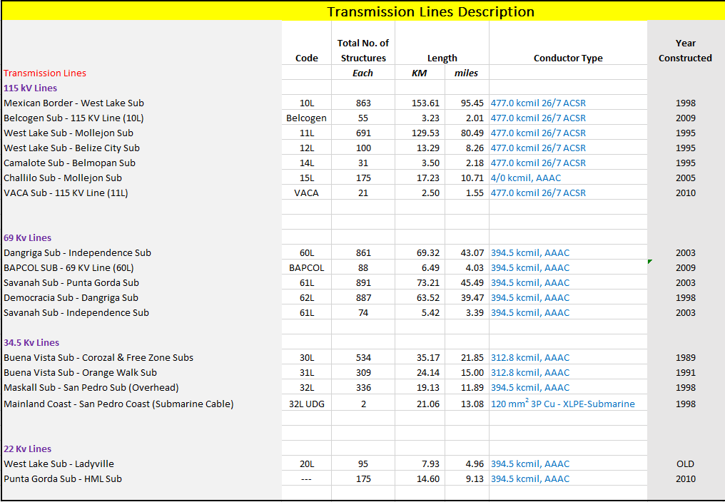

Description | TRANSFORMERS
Chan Chen Substation | SIEMENS 7.5/10MVA +16;-16 OLTC
Corozal Substation | 7.5 MVA transformer DETC 34.5/6.6kV; 2MVA ABB transformer 34.5/22kV +8;-8 OLTC
Corozal Freezone Substation | 4MVA Transformer 34.5/13.2kV ';+5;-5 DETC; 3MVA Transformer 34.5/13.2kV ; +5;-5 DETC;
San Pedrito | 3MVA Transformer 33/6.6kV ; +5;-5 DETC;
Belcogen Substation | ABB 12/16/20 MVA +16;-16 OLTC; 12/13.44/16/17.92/20/22.4MVA 115/13.8kV ; +5;-5 DETC
Orange Walk Substation | 7.5MVA transformer 34.5/6.6kV; +5;-5 DETC; 3/4.2MVA Transformer 34.5/22kV;+5;-5 DETC;
Maskal Substation | 15/20/25 MVA +16;-16 OLTC;
Westlake | 20/22.4MVA DETC +5;-5,+16;-16 OLTC; 20/33MVA 115/13.8kV +5;-5 DETC;
Chetumal Street Substation | 25MVA DETC +5;-5
Belize City Substation | 20MVA DETC +5;-5
La Democracia Substation | 18/24/30MVA DETC +5;-5
Santander Substation | 15/13.44/16/17.92/20/22.4 MVA DETC +5;-5
Camalote Substation | SWITCHING STATION
Belmopan Substation | ABB TRANSFORMER 10/13/16MVA 115/24.94kV; +16;-16 OLTC; DETC +5;-5; T&R 7.5/8.4/9.4/10.5 MVA TRANSFORMER 22.1/11kV;DETC +5;-5; GE TRANSFORMER 115/11kV; 5/5.6/7MVA ;DETC +5;-5
San Ignacio Substation | ABB 10/14MVA +16;-16 OLTC
Mollejon Substation | 31.5MVA DETC +5;-5
VACA substation | 25MVA DETC +5;-5
Chalillo Substation | 10MVA DETC +5;-5
Dangriga Substation | 10/11.2/12.5/14MVA +16;-16 OLTC
Mullins River | ABB 3MVA DETC +7.5;-7.5
BAL Substation | 15/13.44/16/17.92/20/22.4 MVA DETC +5;-5
Independence Substation | 7.5/8.4/9.375/10.5 MVA DETC +5;-5; +16;-16 OLTC
Savannah Substation | SWITCHING STATION
Punta Gorda Substation | 7.5/8.4/9.375/10.5MVA DETC +5;-5 +16;-16 OLTC
San Pedro Substation | 5.4/7MVA; 7.5/10MVA
Caye Caulker Substation
Hydro Maya Substation | 4MVA DETC +5;-5;

8.3 Environmental Design Data
The following climatic and environmental design parameters shall be used as baseline data for the design basis. The Consultant shall verify and, where necessary, supplement these values with more recent site-specific data:

Parameter | Value / Range
Ambient Temperature (Maximum) | 40°C
Ambient Temperature (Minimum) | 10°C
Contamination Level (Average) | Moderate (IEC 60815)
Relative Humidity | 85%
Isokeraunic Level | 45–85 thunderstorm days per year
Solar Radiation | 120 W/m²
Seismic Zone | Zone 1 (ASCE/ANSI 7-88)
Maximum Elevation Above Sea Level | <100 m
Design Wind Speed — Island (100-yr MRI) | 181 mph
Design Wind Speed — Coastal (100-yr MRI) | 165 mph
Design Wind Speed — Inland (100-yr MRI) | 145 mph

8.4 Substation and Transmission Line Location Map
A geographic map of Belize showing the locations of existing Transmission and Sub-Transmission Lines, BEL Substations(Blue Squares), and Generation Sources(Green Circles).
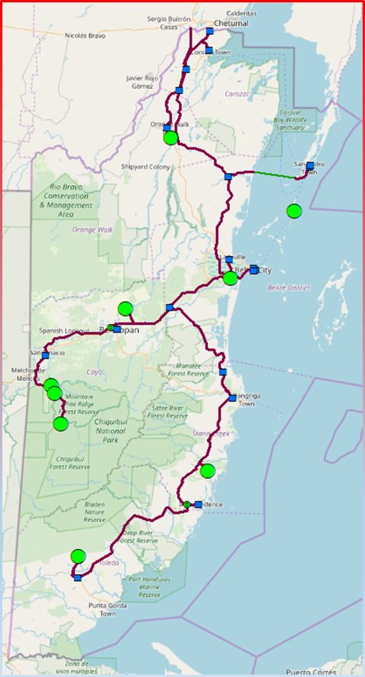

8.5 Proposed LCEP Recommendations
A geographic map of Belize showing the locations of proposed 115 kV Transmission Lines as per LCEP Recommendation.

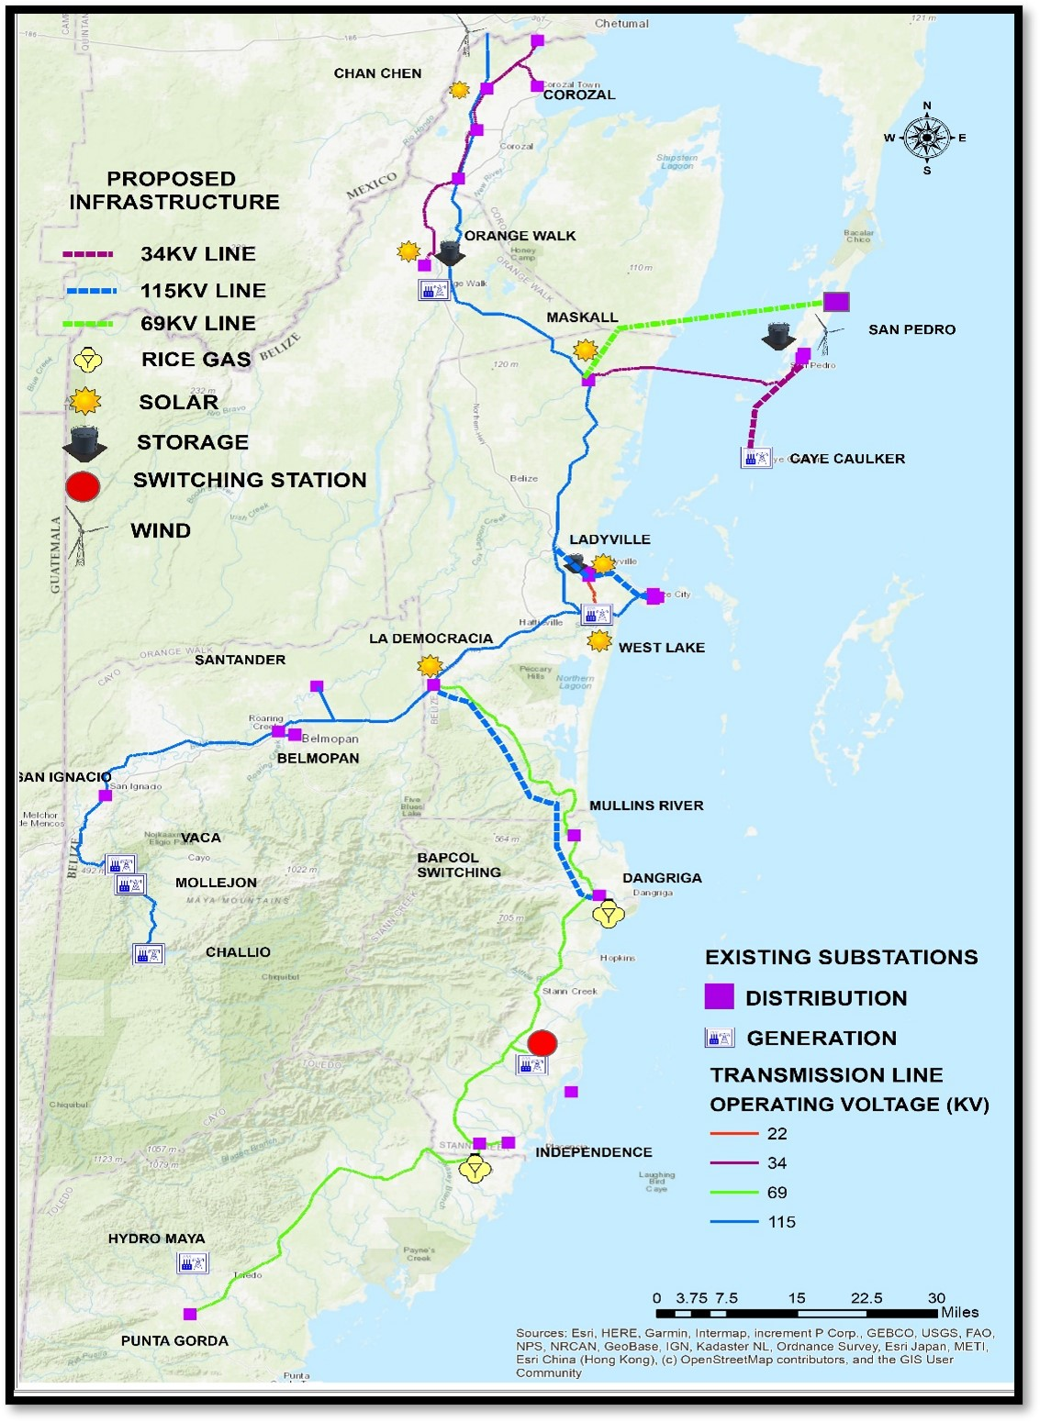

8.6 Design Wind Speeds
A geographic map of Belize showing the designated areas Island, Coastal and Inland Zones
System | Storm MRI (yrs) | Exposed + Island  (MPH) | Coastal (MPH) | Inland (MPH)
Transmission | 100 | 181 | 165 | 145
Distribution | 50 | 120
