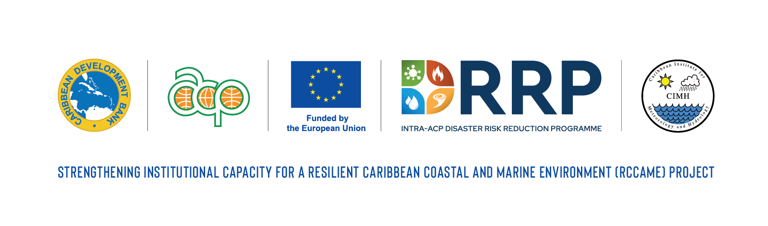

(GA238/REG)

STRENGTHENING INSTITUTIONAL CAPACITY FOR A RESILIENT CARIBBEAN COASTAL AND MARINE ENVIRONMENT (RCCAME) PROJECT

AIR QUALITY INTERN MONITORING & PREDICTION INTERNSHIPS

DRAFT TERMS OF REFERENCE

- BACKGROUND

  - The Caribbean Institute for Meteorology and Hydrology (CIMH) is an Institution of the Caribbean Community (CARICOM) and the technical Organ of the Caribbean Meteorological Organization (CMO). The mandate of the CIMH is to assist in improving and developing the meteorological and hydrological services as well as providing awareness of the benefits of meteorology and hydrology for the economic well-being of the sixteen (16) CMO Member States. This is achieved through training, research, investigations, and the provision of related specialised services and advice.

  - In achieving its mandate, the CIMH has established an affiliation with the University of the West Indies, Cave Hill campus, where its primary responsibility is to deliver the B.Sc. programme in Meteorology in the Faculty of Pure and Applied Sciences. The CIMH is also recognised by the World Meteorological Organization as (a) its designated Regional Training Centre in the Caribbean for Meteorology and Hydrology and related disciplines, (b) its designated Regional Instrument Centre for the Caribbean, (c) a Centre of Excellence in Satellite Meteorology Training, (d) its designated Regional Climate Centre for the Caribbean and (e) the Pan American Node of the Sand and Dust Storm Warning Alerting and Assessment System.

  - The CIMH hosts and manages the Caribbean Centre for Climate and Environmental Simulations established within the last decade in recognition of the region’s need for high-speed computing to support operational and research activities in meteorology, hydrology, climatology and marine science. In addition, the CIMH is the Climate Data Centre for CMO Member States and is recognised as the leading regional centre for research and development related to meteorology, hydrology, agro-meteorology and climate and their applications. More recently, the CIMH established the Regional Marine Forecast Centre to support operational marine forecasting across the region and to provide some of the science essential for improving marine governance and decision making.

  - The CIMH is active in such areas, including but not limited to environmental modeling, hydrological risk impacts forecasting and early warning system development. The CIMH has strong collaborations with other regional institutions such as the Caribbean Disaster Emergency Management Agency (CDEMA), the Caribbean Community Climate Change Centre, the Caribbean Centre for Renewable Energy and Energy Efficiency, the Caribbean Tourism Organization, the Caribbean Development Bank and the Caribbean Agriculture Research and Development Institute in addition to national organisations in CMO Member States. The CIMH also has strong links with the international community inclusive of donor agencies, universities, research and development centres and intergovernmental organisations.

  - Air quality in urban centres in the Caribbean is declining due to increasing urbanization and associated anthropogenic factors such as exhaust from vehicular traffic with noticeable declines observed during rush hour periods. Air quality in such areas is also often impacted by dust generated from construction activities, local and global industrial activity. In the case of the latter, these changes over Barbados are being monitored through the Advanced Global Atmospheric Gases Experiment (AGAGE) facility at Ragged Point, St. Philip, managed by Bristol University. The AGAGE facility samples over 30 chemical species every 20 minutes. Locally, the Government of Barbados, similar to other Governments across the Caribbean, periodically monitors air quality across the island, including in urban areas. The need to monitor air quality over islands in the Caribbean was highlighted during the eruption of the La Soufriere volcano on St. Vincent and the Grenadines in which significant quantities of volcanic ash and gas covered significant portions of the island and neighboring islands with little to no monitoring of air quality over affected islands - little ability to qualitatively link the decline in air quality to health impacts. Similarly, the decline in air quality during periods of elevated brush fire occurrences and the associated health impacts are not typically monitored and documented.

  - To support the more effective integration of air quality information into health early warning systems in the Caribbean, the CIMH, along with regional air quality monitoring partners and health sector professionals and institutions, established the Caribbean Aerosol and Health Network (CAHN). It is recognized that CAHN has the potential to contribute significantly to improving the link between air quality and health outcomes in the region. However, its full potential has not been achieved due to (a) the limited number of air quality observations on many islands in the region which limit the development and implementation of air quality early warning systems and (b) limited funding to support regional training workshops to facilitate interactions between the air quality community and the health sector community. The CIMH has procured one high-quality air quality monitoring station through the EU funded ClimSA programme - one to be placed on St. Vincent and the Grenadines and a possible second to be placed at CIMH in Barbados. It is expected that these stations will form the cornerstones of emerging national air quality monitoring systems in both countries. In a complementary effort, at least two air quality monitoring stations identical to those procured under the ClimSA programme will be deployed in the western Caribbean, to jumpstart expansion of systematic air quality measurements on those islands and to transfer knowledge to identify air quality products and services of interest to the health sector.

  - Over the last decade, the CIMH has embarked on programmes that support air quality monitoring and prediction across the region and have linked these to health and energy impacts. In 2017, the WMO designated the CIMH as the Pan American Node in its Sand and Dust Storm Warning and Advisory and Assessment System (SDS-WAS) platform. A key goal of the Node is to convert dust observations and predictions to actionable information for the health sector and other relevant sectors such as the energy sector.

OBJECTIVES

  - The focus of this internship is to support the expansion of air quality monitoring and prediction activities across the region and in particular the member states of the CIMH and the borrowing member countries of CDB.

SCOPE OF WORK

  - The specific duties and responsibilities of the intern include:

    - Site reconnaissance and placement of air quality monitoring equipment.
    - Support for the installation and commissioning of air quality monitoring equipment.
    - Support for the enhancement of air quality modelling platforms at the CIMH.

QUALIFICATIONS AND EXPERIENCE

  - The intern is required to have recognised credentials in either Atmospheric Science, Meteorology or related disciplines. The candidate may be currently registered in an MSc or PhD programme or have completed the BSc (with First Class Honours or Upper Second Class Honours), in the last 1-3 years.In addition, the intern should have:

    - Basic knowledge of meteorological observation/modelling platforms;
    - Experience working within the Caribbean;
    - Excellent research, communication and interpersonal skills, with the ability to engage and collaborate with diverse stakeholders;
    - Proficiency in English is essential.

REPORTING AND DELIVERABLES

  - The Intern will prepare monthly progress reports and a final report of internship to the Project Coordinator.

INTERNSHIP ARRANGEMENTS AND DURATION

  - The remunerated internship contract will be for a duration of not exceeding seven months. The candidates are expected to reside in Barbados for the duration of the internship unless otherwise agreed. Overseas travel may be required.

