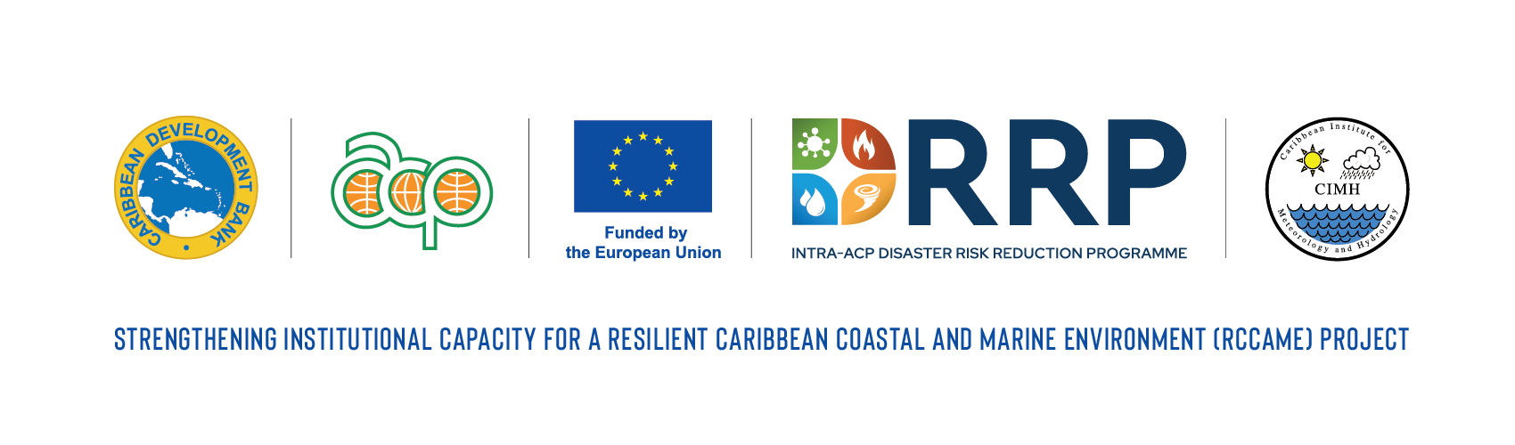
GA238 /REG

DRAFT TERMS OF REFERENCE
CONSULTANCY SERVICES FOR THE DEVELOPMENT OF A REGIONAL STRATEGY FOR THE EXPANSION OF AIR QUALITY MONITORING AND PREDICTIONS

- BACKGROUND

Air quality in urban centres in the Caribbean is declining due to increasing urbanization and associated anthropogenic factors such as exhaust from vehicular traffic with noticeable declines observed during rush hour periods. Air quality in such areas is also often impacted by dust generated from construction activities, local and global industrial activity. In the case of the latter, these changes over Barbados are being monitored through the Advanced Global Atmospheric Gases Experiment (AGAGE) facility at Ragged Point, St. Philip, managed by Bristol University. The AGAGE facility samples over 30 chemical species every 20 minutes. Locally, the Government of Barbados, similar to other Governments across the Caribbean, periodically monitors air quality across the island, including in urban areas. The need to monitor air quality over islands in the Caribbean was highlighted during the eruption of the La Soufriere volcano on St. Vincent and the Grenadines in which significant quantities of volcanic ash and gas covered significant portions of the island and neighbouring islands with little to no monitoring of air quality over affected islands - little ability to qualitatively link the decline in air quality to health impacts. Similarly, the decline in air quality during periods of elevated brush fire occurrences and the associated health impacts are not typically monitored and documented.

To support the more effective integration of air quality information into health early warning systems in the Caribbean, the CIMH, along with regional air quality monitoring partners and health sector professionals and institutions, established the Caribbean Aerosol and Health Network (CAHN). It is recognized that the CAHN has the potential to contribute significantly to improving the link between air quality and health outcomes in the Region. However, its full potential has not been achieved due to (a) the limited number of air quality observations on many islands in the region which limit the development and implementation of air quality early warning systems and (b) limited funding to support regional training workshops to facilitate interactions between the air quality community and the health sector community. The CIMHis in the process of procuring at least one high-quality air quality monitoring station through the EU funded ClimSA Programme - one to be placed on St. Vincent and the Grenadines and a possible second to be placed in Barbados. It is expected that these stations will form the cornerstones of emerging national air quality monitoring systems in both countries. In a complementary effort, at least two (2) air quality monitoring stations identical to those procured under the ClimSA Programme will be deployed in Belize and Jamaica to jumpstart expansion of systematic air quality measurements on those islands and transfer knowledge through the CAHN to identify air quality products and services of interest to the health sector.

Over the last decade, the CIMH has embarked on programmes that support air quality monitoring and prediction across the region and have linked these to health and energy impacts. In 2017, the WMO designated the CIMH as the Pan American Node in its Sand and Dust Storm Warning and Advisory and Assessment System (SDS-WAS) platform. A key goal of the Node is to convert air quality data and information from disparate sources to actionable information for the health sector and other relevant sectors such as the energy sector.

- OBJECTIVES

The focus of this consultancy is to develop a strategy for expanded air quality monitoring and predictions to support early warning systems and impact-based forecasting in the region and in particular the member states of the CIMH and borrowing member countries of the Caribbean Development Bank (CDB).

- SCOPE OF WORK

  - Within the framework of the Caribbean Action for Resilience Programme, the specific duties and responsibilities of the consultant include:

- The review of existing air quality monitoring and prediction platforms in the Region;

- The development of a regional strategic framework for expanding air quality monitoring and predictions in the Caribbean; and

- Integration of air quality monitoring and predictions into impact-based forecasting workflows

- QUALIFICATIONS AND EXPERIENCE

  - The consultant should hold a BSc in either Atmospheric Science, Meteorology or related disciplines with a strong preference given to candidates with MSc and PhD degrees. In addition, the consultant should have:

    - At least seven (7) years of relevant professional experience with direct responsibility for the operation, management, development, or implementation of air quality monitoring and/or modelling platforms; including experience integrating air quality monitoring data and predictive products into impact-based forecasting workflows and decision-support systems.

    - Proven experience developing strategic frameworks

    - Experience working within developing countries, particularly in the Caribbean;

    - Excellent communication and interpersonal skills, with the ability to engage and collaborate with diverse stakeholders; and

    - Proficiency in English is essential. Proficiency in French or Dutch is an asset.

- REPORTING AND DELIVERABLES

  - The Consultant will report to the Project Coordinator and is required to produce the following deliverables:

    - Inception Report summarising inception meeting findings. The report should also include an updated proposal/implementation plan for the consultancy.

    - Assessment Report - including a review of existing air quality monitoring and prediction platforms in the region.

    - Report on execution of consultation sessions with relevant regional stakeholders for the finalization of the regional strategic framework.

    - Regional strategic framework for expanding air quality monitoring and prediction.

    - Report/Presentation on regional strategic framework inclusive of the Integration of Impact-based Forecasting Workflows

- DURATION

6.01 The contract will be for a total of 37.5 days over a duration not exceeding four (4) months.

